A WEB-BASED TOOL FOR REPORTING AND RECOVERING LOST ITEMS FOR BUSITEMA UNIVERSITY STUDENTS NAGONGERA
By
MUSITWA AMOS FRED
BU/UP/2023/1749
DEPARTMENT OF COMPUTER STUDIES
FACULTY OF SCIENCE AND EDUCATION
A PROJECT REPORT SUBMITTED TO THE FACULTY OF SCIENCE AND EDUCATION IN PARTIAL FULFILLMENT FOR THE AWARD OF BACHELOR IN SCIENCE AND EDUCATION
BUSITEMA UNIVERSITY
SUPERVISORS
DR. ANGOLE RICHARD
AND
MR. MUSANA EDDI

JULY, 2026

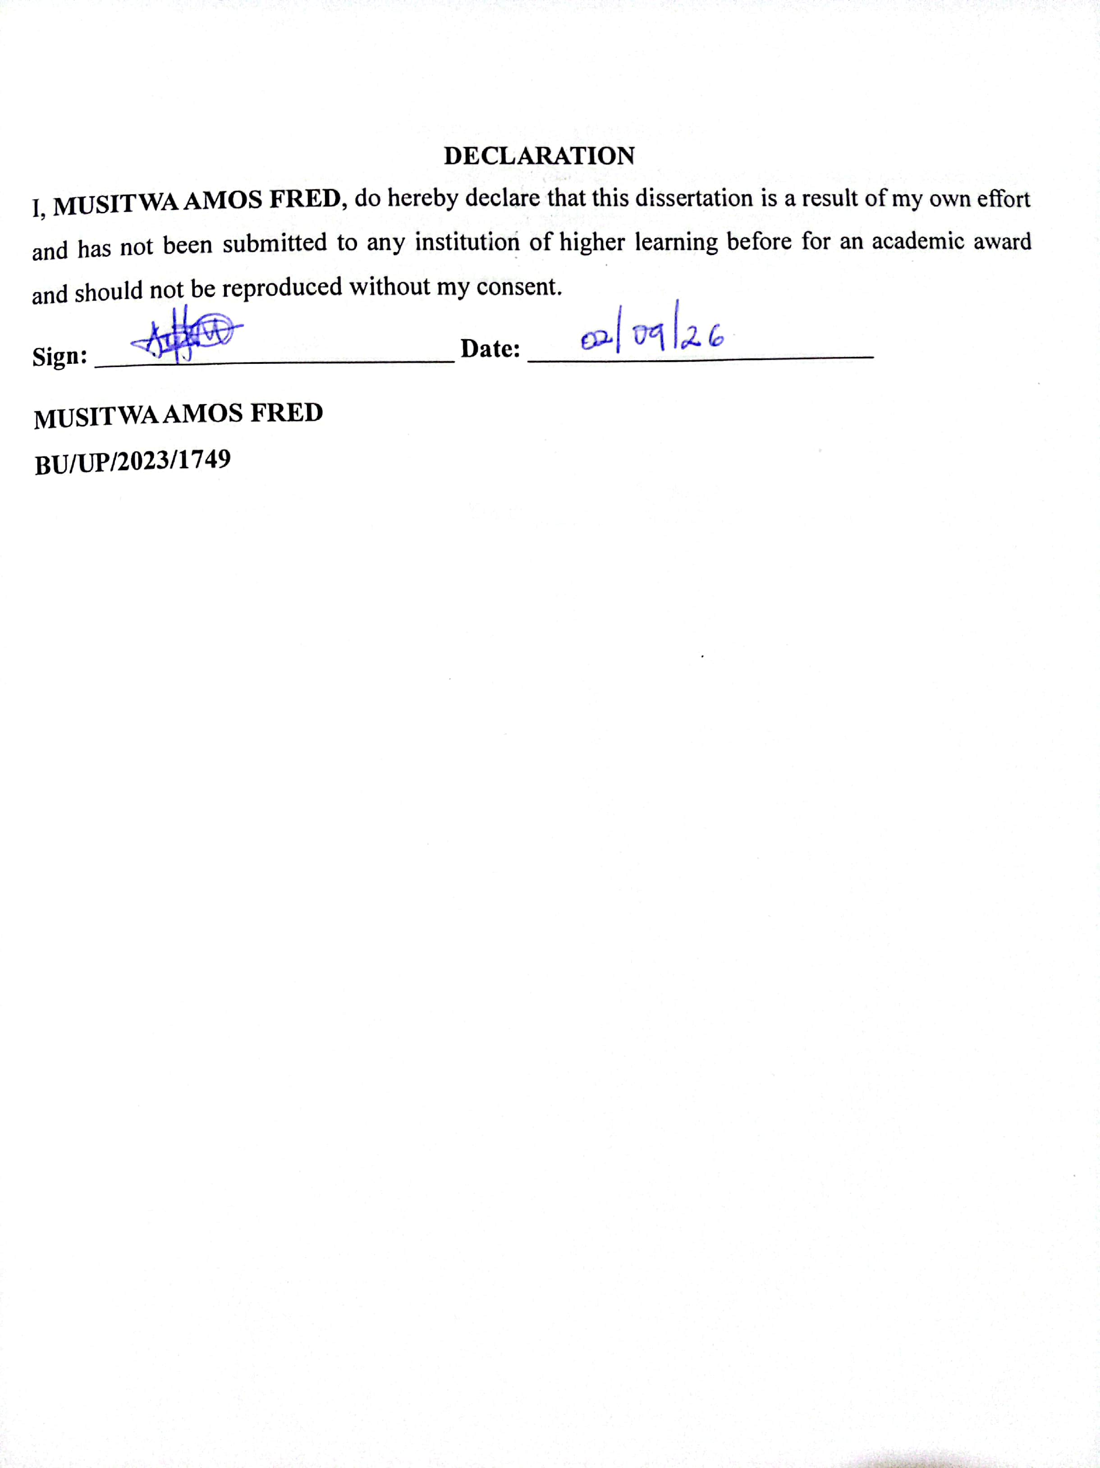
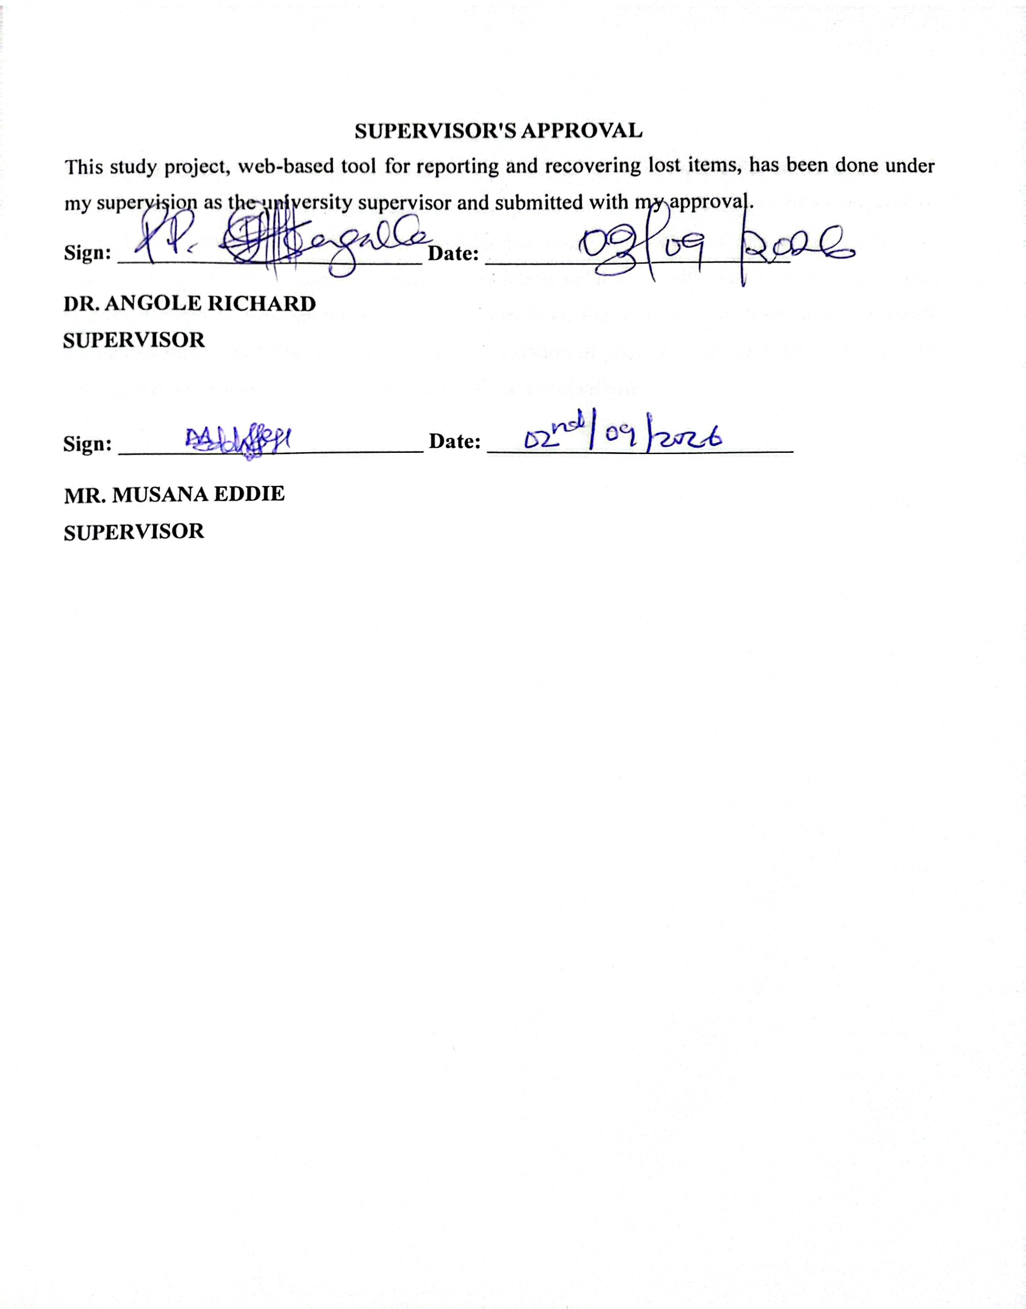

DEDICATION
I thank the Almighty God who has successfully enabled me to complete the entire course with the dissertation. In a special way, I dedicate this project to my entire family members especially my parents for their entire efforts, my brothers and sisters for their kind and loving hearts, my supervisor Mr. Musana Eddie, and finally to my fellow colleagues who have tried their level best to bring me up to this far morally and this has been the source of courage and inspiration throughout this school life. This work is a manifestation of your prayers and hard work, may the Almighty God provide you all with more of life as a special gift.

ACKNOWLEDGEMENT
I am extremely grateful to my research supervisors Dr. Angole Richard and Mr. Musana Eddie who were there all the time for me, for his consistent corrections and guidance which has enabled me to complete this project. I would like to thank my lecturers for the knowledge rendered to me in the field of system analysis and design which I applied in my system. I am highly indebted to my dear brothers Kitiyo Grant and Mugamba Crispus . It is from your efforts, advice, support above all prayers that has made my academic journey a success. In a special way, I would like to extend my sincere appreciation to all my siblings. May the Almighty God provide you abundantly and may the joy of the lord be with you always.
I would also like to thank my dear colleagues, course mates and lecturers at the faculty of science and education, Busitema university who provided a good study environment and supported me throughout the entire course.
I would have cheated myself if I do not acknowledge the role played by my teachers from the primary level up to university. They definitely laid the foundation upon which this degree course picked. Lastly and importantly, I would like to faithfully thank the Almighty God who offered me the gift of life, courage, determination and wisdom. His grace and mercy have enabled me to reach at this level which was my dream and in him I hope for greater heights.

Table of Contents
DECLARATION i
SUPERVISOR'S APPROVAL ii
DEDICATION iii
ACKNOWLEDGEMENT iv
LIST OF ACRONYMS. x
ABSTRACT xii
CHAPTER ONE: 1
INTRODUCTION 1
1.1 Background of the Study 1
1.2 Statement of the Problem 2
1.3 Main Objective 3
1.4 Specific Objectives 3
1.5 Scope 3
1.5.1 Content Scope 3
1.5.2 Geographical Scope 3
1.5.3 Time Scope 4
CHAPTER 2 5
LITERATURE REVIEW 5
2.1 Introduction 5
2.2 Determining Requirements for a Web-Based Lost Item Recovery System 5
2.2.1 The Problem of Lost Items in Educational Institutions 5
2.2.2 Inefficiencies of Traditional and Semi-Digital Methods 6
2.2.3 Functional Requirements 7
2.2.4 Non-Functional Requirements 7
2.2.5 Data Requirements and Matching Techniques 8
2.3 Designing a System with a Multi-Level Administrative Control Structure 8
2.3.1 Review of Existing Systems 8
2.3.2 AI-Enabled Systems 9
2.3.3 Mobile-First Systems 9
2.3.4 The Gap in Administrative Control Structures 9
2.3.5 Proposed Multi-Level Administrative Hierarchy 10
2.4 Implementing a Functional System Using Appropriate Technologies 11
2.4.1 Technology Stack Selection 11
2.4.2 Development Environment 11
2.4.3 Matching Approach for Resource-Constrained Environments 11
2.5 Testing and Validating the System 12
2.5.1 Software Testing Approaches 12
2.5.2 Security Testing 12
2.5.3 Technology Acceptance Evaluation 12
2.6 Synthesis and Research Gap 13
CHAPTER THREE 14
METHODOLOGY 14
3.1 Introduction 14
3.2 Research Design 14
3.3 Study Area and Population 14
3.4 Sampling Techniques 15
3.5 Data Collection Methods and Instruments 16
3.5.1 Interviews 16
3.5.2 Document Review 17
3.5.3 Questionnaire 17
3.6 Data Analysis Methods 18
3.7 System Design 18
3.8 System Implementation 18
3.9 System Testing and validation 19
3.9.1 Unit Testing 19
3.9.2 Integration Testing 19
3.9.3 System Testing 20
3.9.4 User Acceptance Testing (UAT) 20
3.10 Ethical Considerations 20
CHAPTER FOUR 21
FIELD STUDY AND SYSTEM DESIGN 21
4.1 Introduction 21
4.2 Background information of the Current System 21
4.3 System Analysis 22
4.3.1 Findings from Student Questionnaires 22
4.3.2 Findings from Interviews with Chairpersons and Dean of Students 25
4.3 Strength of the Current System 26
4.4 Weaknesses of the Current System 26
4.5 System Requirements 27
4.5.1 Functional Requirements 28
4.5.2 Non-functional Requirements 29
4.6 System Design 29
4.6.1 Architectural Design 29
4.6.2 System Context Diagram 31
4.6.3 Data Flow Diagram (DFD) 33
4.6.4 Use Case Diagram 36
4.6.5 Sequence Diagram 37
4.6.6 Entity Relationship Diagram (ERD) 38
CHAPTER FIVE 43
IMPLEMEMTATION AND TESTING 43
5.1 Introduction 43
5.2 Login Interface Design 43
5.3 User Registration Interface 44
5.4 Admin User Management Interface 44
5.5 Report Lost Item Interface 45
5.6 Report Found Item Interface 46
5.7 Dashboard Interface for Chairperson 46
5.8 Dashboard Interface for Dean 47
5.9 Claim Management Interface 47
5.10 Escalation Management Interface 48
5.11 System Testing 48
5.11.1 Unit Testing 48
5.11.2 Integration Testing 48
5.11.3 Security Testing 49
5.11.4 User Acceptance Testing 49
CHAPTER SIX 50
DISCUSSION, CONCLUSIONS, RECOMMENDATIONS AND FUTURE WORK 50
6.1 Introduction 50
6.2 Discussion of Results 50
6.2.1 Determination of System Requirements 50
6.2.2 System Design 51
6.2.3 System Implementation 51
6.2.4 System Testing 52
6.3 Conclusion 53
6.4 Recommendations 53
6.5 Limitations and Future Work 54
REFERENCES 55
APPENDICES 59
Appendix i: Interview Guide For Requirements Gathering 59
Appendix ii: Questionnaire For Requirements Gathering 59

LIST OF FIGURES
Figure 1:Architectural Design 31
Figure 2: Context Diagram 33
Figure 3: Data Flow Diagram 36
Figure 4:Use Case diagram 37
Figure 5:sequence Diagram 38
Figure 6:Entity Relationship Diagram 39
Figure 7:Login Interface Design 43
Figure 8: User Registration Interface 44
Figure 9:Admin User Management Interface 45
Figure 10:Report Lost Item Interface 45
Figure 11:Report Found Item Interface 46
Figure 12:Dashboard Interface for Chairperson 46
Figure 13:Dashboard Interface for Dean 47
Figure 14: Claim Management Interface 47
Figure 15:Escalation Management Interface 48

LIST OF TABLES
Table 1: Sample Size Representation 16
Table 2: System Users and Their Requirements 28

LIST OF ACRONYMS.
AI Artificial Intelligence
API Application Programming Interface
BLOB Binary Large Object
CBAM Convolutional Block Attention Module
CSS Cascading Style Sheets
DFD Data Flow Diagram
ERD Entity Relationship Diagram
GFLOPs Giga Floating Point Operations Per Second
HTML HyperText Markup Language
HTTP HyperText Transfer Protocol
HTTPS HyperText Transfer Protocol Secure
ICT Information and Communication Technology
IDE Integrated Development Environment
JSON JavaScript Object Notation
MySQL My Structured Query Language
ORM Object-Relational Mapping
PHP PHP: Hypertext Preprocessor
PWA Progressive Web Application
QR Quick Response
RAD Rapid Application Development
RBAC Role-Based Access Control
RDBMS Relational Database Management System
SDLC Software Development Life Cycle
SMS Short Message Service
SQL Structured Query Language
SSADM Structured Systems Analysis and Design Methodology
UAT User Acceptance Testing
UML Unified Modeling Language
USSD Unstructured Supplementary Service Data
UTAUT Unified Theory of Acceptance and Use of Technology
WHO World Health Organization
XAMPP Cross-Platform (X), Apache (A), MariaDB (M), PHP (P), Perl (P)

ABSTRACT
This is a computerized web-based lost item reporting and recovery system project study that was carried out at Busitema University Faculty of Science Education, Nagongera Campus. The main objective of the study was to develop a web-based tool for reporting and recovering lost items to address the challenges of lost belongings on campus, improve recovery rates, and enhance the overall campus experience for students and staff.
To come up with the system, data was collected through interviewing students and some administrators as well as observation, questionnaires, and focus group discussions. The data collected was analyzed and then used to design and implement the system using RAD model approach.
The system was developed using the Unifying Modeling Languages with frontend and backend interfaces with a database system. The developing software tools included PHP, HTML, JavaScript, CSS, Bootstrap, Xampp together with MYSQL. The database stores records of lost items, found items, claims, users, and other related information. The system also enables the Dean of Students, Chairpersons, System Administrator, and other system users to update, edit, delete, view, and add new records and manage the escalation process for claims

CHAPTER ONE:

INTRODUCTION

1.1 Background of the Study
The misplacement of personal belongings is a universal human experience, yet in the dynamic and densely populated environment of a university campus, it becomes a recurring logistical and emotional challenge. The confluence of high foot traffic, shared learning spaces such as libraries and lecture halls, and the constant movement of students between academic, residential, and social zones creates frequent opportunities for items to be lost or misplaced (Zhou et al., 2024; Poojitha, Prithvi, Priyanka, & Prathana, 2026). Research indicates that individuals can spend an average of 2.5 days per year searching for lost items, resulting in significant economic costs and psychological distress (Jiang, Mao, & Kang, 2019). For students, who often operate on limited budgets, the loss of essential items such as laptops, textbooks, identification cards, or mobile phones can be devastating, disrupting academic progress and causing considerable anxiety (Castro, David, De Silva, Roxas, & Macaspac, 2021).
At Busitema University, Faculty of Science and Education, Nagongera Campus, this problem is particularly acute. The current methods for managing lost and found items are fragmented, relying on a decentralized mix of physical bulletin boards, word-of-mouth, and unsupervised WhatsApp groups. These approaches suffer from severe limitations, including limited visibility of information, a complete lack of centralized coordination, no accountability or audit trail, and significant privacy and security risks for users who must share personal contact details in public forums (Tan & Chong, 2023; Salha & Pal, 2025; Suchana, Alam, Meem, Turjo, & Khan, 2021). Empirical evidence from similar institutions confirms that recovery rates using such conventional methods remain dismally low, often below 40 to 50 percent (Raut, Mali, Malkunak, Mandhane, Mandke, & Wanjale, 2026; Bienvenu, 2025).
While digital solutions for lost and found management have emerged in commercial sectors such as hospitality and travel (Slashdot Media, 2023; Sharkey, 2013), these are ill-suited for the unique social, organizational, and infrastructural context of a university campus. Academic prototypes have demonstrated the feasibility of web-based systems (Murugiah & Mat Nawi, 2025; Lasagas et al., 2025; T, Abhiram, Ashok Krishnan, Manjith, Vishnu, & Ambarish, 2024) and even AI-enabled platforms using image recognition (Zhou et al., 2024; Jaspin, Kaviya, & Jane Afra, 2026). However, a critical gap remains. Most existing systems employ a flat, two-tier administrative structure with a single administrator and general users. This model lacks the formal separation of duties, clear verification pathways, and hierarchical escalation procedures necessary to handle ownership disputes, high-value items, and policy enforcement with integrity and accountability (Florida A&M University, 2019; UMBPD, n.d.; Penn State University, 2020). Furthermore, few systems have been designed specifically for the resource constraints of a Ugandan university, where solutions must be low-cost, deployable on standard hardware, and manageable by staff with limited technical support. Therefore, there is a clear and urgent need for a purpose-built, administratively robust web-based tool that addresses these specific contextual challenges.

1.2 Statement of the Problem
The lack of an efficient, centralized, and accountable system for managing lost and found items at Busitema University Nagongera Campus has created a persistent and multi-faceted problem. Students and staff who lose valuable personal belongings face a frustrating and often fruitless search, relying on notice boards, chance encounters, or unreliable social media channels. A significant majority of students who lose items fail to recover them, leading to unnecessary financial burden, academic disruption, and psychological distress (Tan & Chong, 2023; Castro et al., 2021). The current fragmented system relying on physical bulletin boards, word-of-mouth, and decentralized WhatsApp groups is fundamentally inefficient. It suffers from information loss and low visibility, a lack of central coordination, no means of verifying claims or tracking the status of reported items, and serious privacy risks for users who must share personal contact information openly (Suchana et al., 2021; Salha & Pal, 2025). There is no mechanism for matching found items with lost reports, and no formal process for escalating disputes or handling high-value items with the necessary care and accountability. While commercial and academic digital solutions exist, they are either too expensive, not context-appropriate for a Ugandan campus, or lack the robust, multi-level administrative control structure required to ensure fairness, transparency, and trust (David, Catapang, Pabilando, Dala, Marcos, & Lacasandile, 2024). This study, therefore, addresses the problem by designing, implementing, and validating a web-based lost item reporting and recovery tool. This tool is specifically tailored to the organizational structure, resource constraints, and user needs of the Busitema University community, incorporating a four-level administrative hierarchy and essential features for effective and accountable lost and found management.

1.3 Main Objective
To develop a web-based tool for reporting and recovering lost items for Busitema University students and staff at the Nagongera Campus.

1.4 Specific Objectives
The following specific objectives guide this study:
- To review existing literature and determine requirements on web-based lost item reporting and recovery systems.
- To design a web-based tool for reporting and recovering lost items.
- To implement a functional web-based tool for reporting and recovering lost items.
- To test and validate the system.

1.5 Scope

1.5.1 Content Scope
The content scope of this project encompasses the development of a comprehensive web-based lost and found management system featuring a unique four-level administrative hierarchy (Students, Chairpersons, Dean of Students, and System Administrator) with role-based access control. The system will include intuitive interfaces for reporting lost and found items with descriptions, categories, locations, dates, and photo uploads; robust search and filtering capabilities; a formal claim submission and tracking mechanism allowing users to provide proof of ownership and monitor real-time status; role-specific administrative dashboards for claim verification and escalation management; automated email notifications for matches and status changes; comprehensive audit logging for accountability; and formal escalation pathways enabling Chairpersons to refer complex or high-value claims to the Dean of Students for final adjudication. The system will not include mobile applications, advanced AI-based image recognition beyond basic photo uploads, SMS notifications, or integration with the university's central student information system.

1.5.2 Geographical Scope
The deployment and evaluation of the tool will be confined exclusively to the Busitema University Faculty of Science and Education at the Nagongera Campus.

1.5.3 Time Scope
The development and academic evaluation of this tool will be conducted within the timeline of the three months from March -May 2026 academic year, as required for the partial fulfillment of the Bachelor of Science in Education degree.
1.6 Significance of the Study
This study is important because it will create a centralized web-based tool that makes reporting and recovering lost items more efficient. The proposed tool will have a clear administrative structure with specific roles for System Administrators, the Dean of Students, Chairpersons, and regular users. This ensures accountability and transparency (UMBPD, n.d.). By improving how lost items are managed, this tool will reduce stress for students, help them recover their belongings faster, and create a more supportive campus environment.
Furthermore, this study holds significant value for future researchers in the field of information systems, educational technology, and human computer interaction. It provides a documented case study of developing a context-specific solution for a resource-constrained environment. The findings, including user requirements, design model, and the novel four-level administrative hierarchy, can serve as a foundational reference for researchers aiming to design or evaluate similar systems in other academic institutions. The study also highlights the practical challenges and limitations of implementing such systems, such as manual matching processes and the need for broader connectivity, offering a clear direction for future work in areas like AI-driven matching and integrated communication channels.

CHAPTER 2

LITERATURE REVIEW

2.1 Introduction
This chapter presents a critical and systematic review of existing literature, technological solutions, and institutional policies relevant to the development of a web-based lost item reporting and recovery system. The review is organized according to the study's four specific objectives: (1) determining system requirements, (2) designing a system with a multi-level administrative control structure, (3) implementing a functional system using appropriate technologies, and (4) testing and validating the system. Particular attention is paid to administrative control structures, user acceptance factors, emerging technologies such as fuzzy matching and Artificial Intelligence (AI), and the applicability of existing solutions to the unique context of a university campus in a resource-constrained setting (Saunders, Lewis, & Thornhill, 2023).

2.2 Determining Requirements for a Web-Based Lost Item Recovery System
The first objective is to review existing literature and conduct a field study to determine the functional, non-functional, and administrative requirements for a lost item recovery system tailored to the Busitema University context.

2.2.1 The Problem of Lost Items in Educational Institutions
Losing personal belongings is a pervasive and frustrating experience on university campuses, where high foot traffic, shared spaces such as libraries and lecture halls, and constant student mobility create frequent opportunities for misplacement (Zhou et al., 2024; Poojitha, Prithvi, Priyanka, & Prathana, 2026). Research indicates that individuals spend an average of 2.5 days per year searching for lost items, resulting in significant economic costs and psychological distress (Jiang, Mao, & Kang, 2019). Common lost items include student identification cards, mobile phones, wallets, keys, laptops, headphones, and textbooks (Lasagas et al., 2025; Zhou et al., 2024; Shahzan & Arbaiy, 2025).
The consequences extend beyond financial loss. Students experience stress, anxiety, and academic disruption (Castro, David, De Silva, Roxas, & Macaspac, 2021). Moreover, the absence of a standardized recovery system means that even when honest individuals find lost property, there is often no reliable pathway for return (Bliemel, Mery Keitel, & Key, in press). This results in low recovery rates, wasted resources, and diminished campus trust.

2.2.2 Inefficiencies of Traditional and Semi-Digital Methods
Most university campuses rely on fragmented methods for lost and found management, including physical bulletin boards, word-of-mouth, and decentralized social media groups such as WhatsApp and Facebook (Castro et al., 2021; Salha & Pal, 2025; Tan & Chong, 2023). These methods suffer from several inherent weaknesses when analyzed through the lens of internal control principles (Florida A&M University, 2019).
First, limited visibility and permanence plague these approaches. Notices on bulletin boards are quickly buried, while social media messages are rapidly displaced by unrelated content, causing critical information to decay rapidly. Second, there is a profound lack of centralization. With no single authoritative information source, students must monitor multiple channels, leading to fragmented communication and missed matching opportunities.
Third, search and matching processes are highly inefficient, relying on manual scrolling through disparate channels. Fourth, current methods provide no accountability or audit trail, making it impossible to reliably track report status or verify chain of custody, which leads to ownership disputes and lack of trust (UMBPD, n.d.). Finally, sharing personal contact information in public WhatsApp groups exposes users to privacy violations and harassment (Suchana, Alam, Meem, Turjo, & Khan, 2021).
Empirical evidence underscores these inefficiencies. A survey revealed that while approximately 56% of students use social media to report lost items, they express low satisfaction with this method and strongly desire a dedicated, centralized platform (Tan & Chong, 2023). Recovery rates using conventional methods remain below 40 to 50 percent (Raut, Mali, Malkunak, Mandhane, Mandke, & Wanjale, 2026). Bienvenu (2025) further notes that fragmented reporting leads to mismatches and delayed recoveries, with institutions reporting up to 40 percent increases in recovery rates after implementing digital systems.

2.2.3 Functional Requirements
Across multiple studies, several core functional requirements emerge. Secure user authentication and role-based access control (RBAC) are foundational, requiring support for multiple roles including student, chairperson, dean, and administrator (Murugiah & Mat Nawi, 2025; Surve, Sarkare, & Kadam, 2026; T, Abhiram, Ashok Krishnan, Manjith, Vishnu, & Ambarish, 2024). Intuitive item reporting interfaces must allow users to create reports with title, description, category, date, location, and optional photograph (Jiang et al., 2019; Raut et al., 2026; Pede, Ranawat, Shete, Gole, & Kolhe, 2025).
Powerful search and filtering capabilities are critical for database queries using keywords and filters by category, date, location, and status (Murugiah & Mat Nawi, 2025; Lasagas et al., 2025; Tan & Chong, 2023). A formal claim submission and management process must include digital forms for proof of ownership (receipts or serial numbers) and status tracking through stages such as Pending, Approved, Rejected, or Escalated (Raut et al., 2026; Salha & Pal, 2025; Castro et al., 2021). Automated notifications via email or in-app messages should alert users to potential matches or status changes (Raut et al., 2026; Murugiah & Mat Nawi, 2025; Dhawal, Barai, Jha, Prachi, & Ramchandani, 2025). Finally, audit logging must automatically record all critical actions to ensure accountability and provide a dispute resolution trail (Al-Galal, 2023; UMBPD, n.d.; Florida A&M University, 2019).

2.2.4 Non-Functional Requirements
The system's long-term success depends on quality attributes beyond its feature set, aligning with standard software engineering principles (Pressman, 2014; Sommerville, 2016) and internal control frameworks (Florida A&M University, 2019). Usability is paramount; the interface must be intuitive, simple to navigate, and accessible to users with varying digital literacy, as this is a primary predictor of acceptance (Suchana et al., 2021; Lasagas et al., 2025; Castro et al., 2021). Performance requirements demand quick responses to user actions and efficient handling of concurrent users, especially during peak times (Murugiah & Mat Nawi, 2025; Wadbudhe, Ganesh, Patil, Meshram, Sayyed, & Hedau, 2025).
Security is critical. The system must implement secure authentication through password hashing, data encryption in transit via HTTPS, and protection against common vulnerabilities such as SQL injection (Michail, 2025; Wadho, Meghji, Yichient, Kumar, & Shaikh, 2023). Reliability and availability require stable hosting and regular backups (Salha & Pal, 2025; Penn State University, 2020). Maintainability demands an architecture that allows easy updates, bug fixes, and future enhancements without disrupting operations (Salha & Pal, 2025).

2.2.5 Data Requirements and Matching Techniques
A critical system component is the ability to accurately match lost and found item reports. The fundamental challenge is that user-provided descriptions are often incomplete, vague, or use varied terminology. For example, one user might report a "laptop" while another describes a "notebook computer," or "red bag" versus "crimson handbag." Traditional exact-match keyword searching is insufficient for these scenarios (Data Ladder, 2026).
Fuzzy matching, also known as approximate string matching, addresses this challenge by identifying non-identical strings based on similarity. Algorithms such as Levenshtein distance (edit distance), Jaro-Winkler similarity, and Soundex (phonetic matching) calculate similarity scores between text strings, enabling identification of potential matches even when descriptions are not verbatim (Data Ladder, 2026; Operartis, n.d.).

2.3 Designing a System with a Multi-Level Administrative Control Structure
The second objective is to design a web-based tool incorporating a multi-level administrative control structure with clear separation of duties.

2.3.1 Review of Existing Systems
Commercial solutions such as iLost for Business and ChargerBack serve hospitality, travel, and retail sectors (Slashdot Media, 2023; Sharkey, 2013). However, neither is designed for the unique context of a university campus.
Several academic prototypes have been developed for university environments. Tan and Chong (2023) created a dual-platform solution (web and Android) for the National University of Malaysia, though it lacked intelligent matching. T, Abhiram and colleagues (2024) developed CampusTrace with strong administrative oversight. FindItHere, by Murugiah and Mat Nawi (2025), is a web-based application for Universiti Tun Hussein Onn Malaysia featuring user registration, item reporting with images, search functionality, claim submission, an administrative dashboard, and real-time notifications.
Castro and colleagues (2021) developed AUFound for Angeles University Foundation, comprising a student mobile application and a web-based administrative system. Lasagas and colleagues (2025) created the USTP Panaon Lost and Found Management System using QR code technology. Shahzan and Arbaiy (2025) built the UTHM Lost and Found Management System using PHP, HTML, CSS, JavaScript, and MySQL.

2.3.2 AI-Enabled Systems
AI-enabled systems leveraging machine learning and computer vision have enhanced matching accuracy. LostNet (Zhou et al., 2024) integrates MobileNetV2 with a Convolutional Block Attention Module (CBAM) and perceptual hashing, achieving 96.8 percent accuracy with only 0.67 GFLOPs and 3.5 million parameters. Jaspin, Kaviya, and Jane Afra (2026) proposed a transformer-based system using MPNet for text embeddings and CLIP for visual embeddings, achieving 86 percent accuracy. Smartlofo (Srilatha et al., 2026) uses computer vision and natural language processing, while UniFind (Wadbudhe et al., 2025) leverages AI and cloud services for campus lost and found.

2.3.3 Mobile-First Systems
Recognizing that students primarily access the internet via smartphones, several systems have adopted mobile-first approaches. Jiang, Mao, and Kang (2019) designed a campus platform based on digital map data using Android and map APIs, including push notifications and a reward mechanism. Poojitha and colleagues (2026) developed a smart campus system, while Dhawal and colleagues (2025) created LostLink emphasizing location-based matching.

2.3.4 The Gap in Administrative Control Structures
A significant gap in existing prototypes is the lack of robust administrative structures. Systems such as FindItHere and LostLink employ flat models where a single administrator has excessive authority and no clear pathways exist for handling disputes or high-value items. Castro and colleagues (2021) similarly noted that AUFound relied on a single administrative point within the Office of Student Affairs and Financial Aid.

2.3.5 Proposed Multi-Level Administrative Hierarchy
Drawing on formal property management, institutional internal control frameworks, and multi-campus comparative studies, a more effective model incorporates a multi-level administrative hierarchy with separation of duties (UMBPD, n.d.; University of Alabama Museums, 2020; Penn State University, 2020; Florida A&M University, 2019; David, Catapang, Pabilando, Dala, Marcos, & Lacasandile, 2024). This hierarchy comprises four distinct levels.
At the lowest level, general users (students and staff) may submit lost and found reports, search for items, submit claims with proof of ownership, and track their own report and claim status. They cannot verify claims for others or approve releases.
Above them, Chairpersons represent operational authority. They are responsible for day-to-day review of reports, initial verification of standard low-value claims, matching lost and found items, approving standard releases, and escalating complex or disputed cases.
The Dean of Students occupies the institutional authority level, serving as the final decision-maker for escalated claims, ownership disputes, and high-value or sensitive items such as laptops, passports, or large sums of money. This level ensures consistent policy application and fair dispute resolution.
At the highest level, the System Administrator holds technical authority, responsible for system configuration, managing official user accounts, maintaining database integrity, security monitoring, reviewing audit logs, and overriding records only in exceptional cases of technical error or policy violation. Critically, the System Administrator does not directly approve lost item claims unless there is evidence of system abuse or policy violation.
This hierarchical model ensures accountability by clearly defining permissions and responsibilities while providing a formal escalation pathway for cases that cannot be resolved at lower levels. This separation of duties, a fundamental principle of internal control (Florida A&M University, 2019), represents a significant improvement over the flat administrative models common in existing student projects.

2.4 Implementing a Functional System Using Appropriate Technologies
The third objective is to implement a functional web-based tool using appropriate and accessible open-source technologies.

2.4.1 Technology Stack Selection
The literature consistently supports open-source technologies for web-based systems in resource-constrained educational environments. PHP is a widely used server-side scripting language particularly appropriate for this project. Studies by Murugiah and Mat Nawi (2025) and Castro et al. (2021) successfully implemented lost and found systems using PHP. Its extensive documentation, large community, and compatibility with standard hosting make it an ideal choice.
MySQL is the standard open-source relational database management system that pairs seamlessly with PHP, providing the necessary structure to store and query data for users, items, claims, and audit logs (Jiang et al., 2019; Salha & Pal, 2025). Connolly and Begg (2015) note that MySQL supports various data types including integer, decimal, binary (for BLOBs), text, and datetime, making it suitable for storing images and documents.
For frontend development, HTML, CSS, and JavaScript form the core technologies. The Bootstrap framework is almost universally recommended to ensure a responsive, mobile-friendly interface without extensive custom coding (Castro et al., 2021; Murugiah & Mat Nawi, 2025). Bootstrap provides pre-built components for responsive design, ensuring proper functionality on both desktop and mobile devices.

2.4.2 Development Environment
XAMPP (Apache, MySQL, PHP, Perl) provides a complete local web server environment that simplifies web application setup, allowing developers to focus on coding rather than configuration (Connolly & Begg, 2015). Visual Studio Code serves as an appropriate integrated development environment (IDE) for coding and debugging.

2.4.3 Matching Approach for Resource-Constrained Environments
While advanced AI features represent the technological frontier, they require significant computational resources and large training datasets that may not be feasible in resource-constrained settings such as Busitema University (Zhou et al., 2024; Jaspin et al., 2026). For this context, a practical hybrid approach is recommended: combining fuzzy matching for textual descriptions, category-based filtering for initial narrowing, and manual verification from administrative users for final approval (Murugiah & Mat Nawi, 2025; Raut et al., 2026). This balances automation with reliability and suits the available infrastructure.

2.5 Testing and Validating the System
The fourth objective is to test and validate the system through unit testing, integration testing, security testing, and user acceptance testing with stakeholders.

2.5.1 Software Testing Approaches
According to Pressman (2014), software testing is a critical phase in the development life cycle that ensures the system meets its requirements and functions correctly. Sommerville (2016) identifies several applicable testing levels. Unit testing examines individual modules in isolation. Integration testing verifies correct module interaction. System testing evaluates the complete integrated system against its requirements. Acceptance testing, particularly User Acceptance Testing (UAT), involves end users verifying that the system meets their needs.

2.5.2 Security Testing
Michail (2025) emphasizes that security testing is essential for web applications handling user data. Key security tests include authentication testing (verifying only authorized users can access the system), authorization testing (ensuring users can only access role-appropriate functions), input validation testing (verifying rejection of malformed or malicious input), and session management testing (verifying proper session handling and termination).

2.5.3 Technology Acceptance Evaluation
Several studies have applied the Unified Theory of Acceptance and Use of Technology (UTAUT) to evaluate user acceptance in educational settings. Galura, Reyes, and Pineda (2023) found that performance expectancy, effort expectancy, social influence, and facilitating conditions significantly affect behavioral intention to use a learning management system.
Abbad (2021) applied UTAUT in a developing country context, finding that performance expectancy and effort expectancy were the strongest predictors of behavioral intention. This suggests that for lost item recovery systems to be accepted, they must be perceived as useful (performance expectancy) and easy to use (effort expectancy). Sergeeva and colleagues (2025) further validated the UTAUT2 model for understanding higher education students' technology adoption. Almaiah, Alamri, and Al-Rahmi (2019) identified system quality, information quality, and service quality as key determinants of user satisfaction and acceptance.

2.6 Synthesis and Research Gap
The literature clearly establishes the need for digital lost and found systems in university settings. Several key themes emerge. First, there is general agreement on core functional requirements: user authentication, item reporting, search and filtering, claim management, and notifications (Murugiah & Mat Nawi, 2025; Tan & Chong, 2023; Lasagas et al., 2025; Castro et al., 2021). Second, non-functional requirements including usability, security, and reliability are critical for user acceptance (Suchana et al., 2021; Lasagas et al., 2025; Shahzan & Arbaiy, 2025). Third, fuzzy matching and AI-powered techniques can significantly improve matching accuracy (Zhou et al., 2024; Data Ladder, 2026; Jaspin et al., 2026).
However, a significant gap exists in integrating comprehensive administrative control structures with technical functionality. Most existing systems, whether commercial or academic, either lack clear administrative hierarchies or implement flat structures incapable of handling the complexities of university environments with diverse user populations, varying item values, and the need for dispute resolution. None of the reviewed systems adequately addresses distinct student populations (resident versus non-resident) or provides escalation pathways for high-value items involving multiple authority levels.
Furthermore, limited research applies the UTAUT model to lost and found systems in developing country contexts. Factors such as performance expectancy, effort expectancy, social influence, and facilitating conditions likely affect user adoption of lost and found platforms as well (Abbad, 2021; Sergeeva et al., 2025).

CHAPTER THREE

METHODOLOGY

3.1 Introduction
This chapter describes the methods, tools, and techniques applied to meet the specific objectives of the study. The chapter describes the research design and development approach, study area and population, sampling techniques, data collection methods and instruments, data analysis methods, system design, system implementation, system testing and evaluation, and ethical considerations. The Software Development Life Cycle (SDLC) framework was selected as the guiding approach, providing a structured process that includes system planning, analysis, design, implementation, and testing.

3.2 Research Design
The research design for this study is system development research, which involves the creation and evaluation of a software system to address a real-world problem. The system was developed using Structured Systems Analysis and Design Methodology (SSADM) because it provides a clear, step-by-step approach to system development. The Rapid Application Development (RAD) model was adopted as the development approach. RAD is an adaptive software development approach where a software prototype is rapidly updated based on user feedback and iteratively delivered until it meets all the needs of the client. RAD emphasizes flexibility and iterative development through continuous feedback and refinement.
The RAD model was chosen because it allows for quick delivery of the system, accommodates changes during development, involves users throughout the process, and reduces development time.

3.3 Study Area and Population
The study was conducted at Busitema University Faculty of Science Education, Nagongera Campus, located in Soroti district, Eastern Uganda. This area was chosen due to the existing problems and challenges related to lost item management, particularly the high rate of lost items and low recovery rates among students and staff.
The population involved in the study included students (both resident and non-resident), staff members, Chairpersons (Resident and Non-Resident), and the Dean of Students at Busitema University Nagongera Campus.

3.4 Sampling Techniques
Sampling involves the strategic selection of individuals or a subset from a population, aiming to derive statistical inferences and predict the characteristics of the entire population (Dr. Renu Bisht, 2024). For this study, simple random sampling and purposive sampling were employed.
Simple random sampling was used to select student participants because it provides equal opportunity for each member of the population to be selected, ensuring a fair and unbiased representation. Purposive sampling was used to select key people having knowledge under investigation, including the Dean of Students and Chairpersons.
Advantages of Simple Random Sampling:
Equal Representation: Every student or staff member has an equal chance of being chosen.
Simplicity: The method is straightforward and does not require extensive background information.
Reduced Bias: Since selection is random, researcher bias is minimized.
Ease of Analysis: The data collected is statistically reliable and easier to interpret.
Target Population and Sample Size
The study focused specifically on students and staff members from Busitema University's Faculty of Science Education, Nagongera Campus. A total sample of 20 participants was targeted.

Table 1: Sample Size Representation
Category | Number of Participants
Students (Resident) | 8
Students (Non-Resident) | 9
Administrators (Chairpersons/Dean) | 3
Total | 20
Table 1: Sample Size Representation

3.5 Data Collection Methods and Instruments
Data collection aimed to obtain reliable information to guide system design and implementation. Following Preece (2020), data collection was structured to ensure adequacy, relevance, and accuracy. The following methods and instruments were used:

3.5.1 Interviews
Interviews were conducted as a primary data collection method to gather in-depth, qualitative information from key stakeholders. Semi-structured interviews were used, allowing the researcher to ask pre-determined questions while also having the flexibility to explore emerging themes and follow up on interesting responses.
Interview Process: The researcher conducted face-to-face interviews with the Dean of Students and the two Chairpersons (Resident and Non-Resident). Each interview lasted approximately 20 to 30 minutes. Before each interview, the researcher obtained informed consent from the participants, explained the purpose of the study, and assured them of confidentiality.
Interview Guide: An interview guide was developed with questions covering the following areas:
Current methods used to manage lost and found items
Challenges and limitations of the existing system
Frequency and types of lost items reported
Current verification methods for ownership claims
Handling of disputes and high-value items
Desired features for a digital lost and found system
Preferred administrative structure and escalation procedures
Advantages of Interviews: Interviews allowed the researcher to probe deeper into responses, clarify ambiguous answers, and capture rich, detailed information that could not be obtained through questionnaires alone. The researcher was able to observe non-verbal cues and build rapport with participants, which encouraged honest and thorough responses.
Interview Participants: A total of 3 key informants were interviewed:
- 1 Dean of Students
- 2 Chairpersons (1 Resident, 1 Non-Resident)

3.5.2 Document Review
This tool was used to understand what has been written on the subject matter of web-based lost item reporting and recovery systems. Review of documents enabled the researcher to investigate gaps, problems, and benefits of existing systems.

3.5.3 Questionnaire
A questionnaire was used as the primary data collection tool. Approximately 20 digital forms were distributed via WhatsApp groups to reach students and staff conveniently at Busitema University Nagongera Campus.
Justification for Using Questionnaires:
Efficiency: They enable fast data gathering from a large audience.
Consistency: Uniform questions ensure comparability of responses.
Anonymity: Participants can respond honestly without fear of identification.
Ease of Analysis: Structured data can be statistically analyzed to identify common patterns and user needs.
The questionnaire was adapted from validated instruments used in similar studies (Mukisa et al., 2024; MUSG, 2022) and included sections on demographic information, experience with lost items, awareness of and satisfaction with current mechanisms, features desired in a web-based tool, and preferences regarding the administrative structure and escalation procedures.

3.6 Data Analysis Methods
After the data collection exercise, data analysis of the collected data was done to eliminate inconsistencies, sieve out useful data, and update the system requirements (Lakidi et al., 2023). According to (Sileyew, 2019), the process of analyzing collected data is a translation of the gathered data by different methods through research and refers gathered data to the literature review to construct proper results for the resources and fulfill the purpose.
The qualitative data collected by interviews, observation, document review, questionnaires, and focus groups was analyzed according to qualitative analysis, which is the use of non-quantifiable methods to evaluate information and make decisions. In qualitative analysis, the data collected was structured in a proper sequence, basing on the method of collection (Sileyew, 2019). Thematic analysis was used to identify common themes and patterns in the responses.

3.7 System Design
This describes how the functions of a web-based tool for reporting and recovering lost items for Busitema University Nagongera Campus could be realized. This shall be done through the use of system design tools such as DFDs (Data Flow Diagrams), Context Diagrams, ERDs (Entity Relationship Diagrams) that could be used in the development of the system and its databases.
The architectural and module design shall be integrated to make up the system using UML (Unified Modeling Language) which is an object-oriented language. UML clarifies and specifies the working of the system with the help of the UML standards. The requirements specifications from the requirements analysis shall be studied to prepare the system design which helps in specifying the hardware and software requirements and defines the overall system architecture.

3.8 System Implementation
In the development phase, the individual student was responsible for coding and programming to build the web-based lost item reporting and recovery system based on the design specifications. The RAD methodology's focus on quick iterations and frequent user feedback drove rapid development and adaptation.
The following technologies were used for system implementation:
Frontend Technologies:
HTML (Hyper Text Markup Language): For creating dynamic and interactive web pages
CSS (Cascading Style Sheets): For modifying the appearance of fonts and web pages
Bootstrap: For responsive design and mobile compatibility
JavaScript: For validating system web pages and adding interactivity
Backend Technologies:
PHP: For connecting the system interfaces to the databases and handling server-side logic
Database:
MySQL: For creating the system database and tables that provide a platform from which system information is stored. MySQL supports different data types including primary types such as integer, decimal, binary (for unstructured blobs of data), text (for textual data), and so on.
Development Environment:
Visual Studio Code: As the integrated development environment (IDE)
Xampp Server: Contains MySQL components that enable database creation and management

3.9 System Testing and validation
Testing and validation were performed to confirm that the system functions as intended. According to Bot (2019), validation ensures that software performs accurately, consistently, and meets user expectations. Multiple testing levels were used:

3.9.1 Unit Testing
Individual modules such as item reporting, user registration, role assignment, and escalation triggers were tested separately to ensure correctness. A unit is the smallest testable part of an application.

3.9.2 Integration Testing
This focused on verifying interactions between modules, ensuring smooth data flow and operational consistency (e.g., between the reporting and claim verification modules, and between different administrative levels). This also tested integrations with external services.

3.9.3 System Testing
The fully integrated system was evaluated to ensure compliance with initial specifications and stable overall performance, including stress testing of the administrative hierarchy under various scenarios. System testing was performed on the entire system in the context of the functional requirements and system requirements.

3.9.4 User Acceptance Testing (UAT)
End users including students, Chairpersons, the Dean of Students, and System Administrators simulated real-world scenarios to verify whether the system meets functional requirements and is user-friendly. This specifically tested the escalation pathways, role-based permissions, and overall usability. Feedback from UAT was used to fine-tune the system before deployment.

3.10 Ethical Considerations
The student upheld ethical considerations throughout the project. The following ethical issues were addressed:
Informed Consent: Participants in surveys and interviews were informed about the purpose of the study and their right to withdraw at any time without penalty.
Confidentiality: Participants were guaranteed that their responses would be treated with maximum confidentiality and used for academic purposes only.
Voluntary Participation: Participation in the study was voluntary, and no participant was forced to provide information.
Secure Storage of Data: All collected data was stored securely and accessed only by the researcher for the purposes of the study.
Anonymity: Respondents were assured that their names would not be disclosed in the final report.

CHAPTER FOUR

FIELD STUDY AND SYSTEM DESIGN

4.1 Introduction
This chapter describes the study of the current system, strength of the current system, weaknesses of the Current System, System Requirements (Functional and Non-Functional Requirements), System Design (Context Diagram, Data Flow Diagram, ERD, Use Case Diagram, Sequence Diagram, and Process Diagram).

4.2 Background information of the Current System
The Current Information System for lost item management at Busitema University Nagongera Campus is a decentralized manual system that relies on multiple uncoordinated methods. Students and staff members who lose items currently depend on word-of-mouth communication, posting notices on physical bulletin boards scattered across campus, and sending messages in various WhatsApp groups. The system has no central authority responsible for lost and found items, and there is no standardized procedure for reporting lost items or claiming found ones.
Currently, when a student loses an item, they may post about it in their class or departmental WhatsApp group, hoping someone has seen or found it. Alternatively, they may print or handwrite notices and pin them on notice boards in lecture halls, the library, or the cafeteria. Those who find items often keep them temporarily or give them to a friend or lecturer, but there is no designated lost and found office or coordinator.
These manual processes, lack of centralization, and absence of a structured administrative framework contribute to inefficiencies and low recovery rates. The absence of real-time tracking affects timely matching of lost and found items, and difficulties in verifying ownership impact transparency and accountability.

4.3 System Analysis
The study was carried out at Busitema University Nagongera Campus, and the main purpose of the study was to find out the challenges faced by students and staff in reporting and recovering lost items, as well as the difficulties encountered by administrators (Chairpersons and Dean of Students) in managing lost and found claims. The study involved examining the existing manual and semi-digital system to identify its strengths and weaknesses. The information acquired from the study was gathered by employing semi-structured interviews, focus group discussions, and questionnaires administered to students, Chairpersons, and the Dean of Students. The data collected were analyzed to provide the basis for designing this system.

4.3.1 Findings from Student Questionnaires
A total of 20 students responded to the questionnaire. The survey aimed to understand current lost item reporting practices, challenges faced, technology readiness, and desired features for the system. The findings are presented below.
1. Current methods of reporting lost items
When asked about the methods they currently use to report a lost item, the majority of students admitted to relying on WhatsApp groups. One respondent explained, "I just post in the class WhatsApp group and hope someone has seen it." Another student stated, "I tell my friends and ask them to spread the word. Sometimes I put a notice on the library board." A third respondent simply said, "I use the faculty notice board, but I don't know if anyone checks it."
Out of the 20 respondents, 10 (50%) reported using WhatsApp groups as their primary method. Four students (20%) indicated that they use notice boards. Three students (15%) mentioned relying on word of mouth through friends and classmates. Two students (10%) said they report to their Chairperson. One student (5%) admitted they use no method at all, stating plainly, "I just accept the loss and buy a new one if I can afford it."
2. Challenges in recovering lost items
Students were asked about the difficulties they face when trying to recover a lost item. The responses revealed several significant barriers.
The most common challenge, reported by eight students (40%), was that nobody responded to their report or the information got lost in WhatsApp groups. One student expressed frustration, saying, "My message gets buried by other chats within an hour. Nobody sees it." Another shared a similar struggle: "Even if someone found my item, they don't know how to reach me privately."
Lack of a central place to check was the second most common challenge, cited by six students (30%). One student stated, "I have to check three different WhatsApp groups and two notice boards. It is exhausting." Another said, "There is no single place where all lost items are listed. I don't know where to start looking."
Privacy concerns were identified as a barrier by four students (20%). One student noted, "I had to post my phone number in a public group. After that, strangers started calling me." Another also stated that "I don't feel safe sharing my personal contact information with everyone."
Other challenges included delayed responses, with one student remarking, "Someone found my ID card but took three days to see my message," and another stating, "By the time someone replied, I had already paid for a replacement."
3. Technology access and readiness
To assess the feasibility of a digital intervention, students were asked about their access to devices and internet connectivity.
Regarding device access, 17 students (85%) reported owning a smartphone. One of these students stated confidently, "I have a smartphone and I use it every day." Twelve students (60%) indicated they have regular internet access through mobile data. Three students (15%) reported having access only to basic phones for calls and SMS.
When asked how often they use the internet, 14 students (70%) said daily, 4 students (20%) said weekly, and 2 students (10%) said rarely. The average rating for willingness to use a web-based system was 4.2 out of 5, indicating strong readiness for a digital solution.
4. Recovery success rates
When asked whether they had ever recovered a lost item, only 6 students (30%) reported successful recovery. One student explained, "I was lucky because my friend saw someone pick up my wallet and asked them." Another shared, "Someone returned my phone after seeing my post in a WhatsApp group three days later."
The remaining 14 students (70%) reported that they never recovered their lost items. One student lamented, "I lost my laptop. I reported everywhere. Nothing. I had to repeat the year because my coursework was on it." Another said, "I lost my ID card. I paid 20,000 shillings for a new one because nobody returned it."
5. Perceived helpfulness of a web-based lost item system
Students were asked to rate how helpful they would find a dedicated web-based system for lost and found management on a scale of 1 (Not Helpful) to 5 (Extremely Helpful). The responses indicated strong interest in this feature.
Six students (30%) rated it as "Extremely Helpful." One student responded enthusiastically, "That would save me so much stress." Eight students (40%) rated it as "Very Helpful." Four students (20%) rated it as "Moderately Helpful." Two students (10%) rated it as "Slightly Helpful." No student rated it as "Not Helpful." The average rating was 4.1 out of 5, demonstrating that 70% of students viewed a web-based lost item system as "Very Helpful" or "Extremely Helpful."
6. Desired system features
When asked what features would be most useful in a web-based lost item system, students provided a range of practical requests.
The most common request, from 14 students (70%), was the ability to report lost items with photos. One student asked, "If I can upload a photo of my phone case, it will be easier for someone to identify it."
Twelve students (60%) requested the ability to report found items with photos. Eleven students (55%) wanted search functionality to look for their items. Ten students (50%) requested claim submission with proof of ownership. Nine students (45%) wanted to receive notifications when a potential match is found. Eight students (40%) wanted to be able to track the status of their report or claim.
Notably, 5 students (25%) specifically requested privacy protection, with one commenting, "I don't want my phone number visible to everyone. Only the person who found my item should contact me."

4.3.2 Findings from Interviews with Chairpersons and Dean of Students
Semi-structured interviews were conducted with two Chairpersons (Resident and Non-Resident) and the Dean of Students to understand current practices and desired system features.
Current management practices and limitations (Questions 1-3): The Chairpersons explained that lost items are currently managed informally. One Chairperson stated, "Students bring found items to my office, but I have no formal system to record them. I keep them in a box and wait for someone to claim them." The Dean of Students added, "We receive reports verbally or through handwritten notes. There is no central database. If an item is found in the library and reported to the Dean's office, the student who lost it in the hostel may never know."
The main limitations identified were: no central coordination, no way to match lost and found items automatically, no verification process for claims, and no audit trail for high-value items.
Desired dashboard information (Question 4): The Dean indicated that the most useful information on a digital dashboard would be a list of all recently reported lost and found items, pending claims requiring verification, and the ability to escalate disputed cases. One Chairperson added, "I need to see all items assigned to my hall of residence. I cannot manage items from the entire campus."
Preferred verification and escalation methods (Questions 5-6): The Dean of Students ranked preferred verification methods as follows: requiring proof of ownership (receipts, serial numbers, or photos) as the most reliable; asking descriptive questions about the item as moderately reliable; and verbal confirmation alone as least reliable.
Regarding escalation, both Chairpersons agreed that high-value items (laptops, phones, large sums of money) and disputed claims should be automatically escalated to the Dean of Students for final resolution. One Chairperson noted, "I am a student leader. I cannot be the one to decide who gets an expensive laptop. That should go to the Dean."
Commonly lost items (Question 7): The Dean of Students noted that the most commonly lost items are student ID cards, followed by phones, wallets, keys, and laptops. One Chairperson added, "During exam period, we get many lost pens, calculators, and water bottles. But ID cards are lost every single day."
Perceived helpfulness of a web-based lost and found system (Question 8): The Dean of Students rated a web-based system as 5 (Extremely Helpful), noting that "We currently have no way to track lost items systematically. A digital system would save students money and reduce stress. It would also make our office more accountable."
Desired administrative features (Question 9): The Dean emphasized that the system must have clear roles and permissions. "Students should report items. Chairpersons should verify claims for their halls. Only I should handle disputes and high-value items. The System Administrator should manage technical issues but not approve claims." This confirmed the need for the four-level administrative hierarchy proposed in this study.

4.3 Strength of the Current System
The Current Information System at Busitema University Nagongera Campus gives students a chance to communicate directly with their peers about lost items through WhatsApp groups.
It does not require any specific technical skills or knowledge in ICT to report a lost item.
The system is free and does not require any financial investment.

4.4 Weaknesses of the Current System
Difficulty in easily retrieving a record of lost or found items at a later time.
The existing system lacks centralization, automation, integration, and user support, leading to inefficiencies in handling lost item data.
The university relies on manual communication methods, resulting in time-consuming procedures and hindering effective item matching and claim processing.
WhatsApp messages and bulletin notices tend to get lost or fade with time, leading to information loss.
The process of manually searching for information consumes a lot of time, making the system slow.
The Dean of Students and other administrators cannot access a centralized view of all lost and found activities without physically collecting information from various sources.
The system is prone to errors due to its fragmented nature.
Some lost items are never reported or claimed because students do not know where to report.

4.5 System Requirements
A number of tools were used to analyze the data collected from Busitema University Nagongera Campus such as interviews, observation, and questionnaires, from which useful information was extracted, identifying and listing the Functional and Non-Functional Requirements in an orderly and organized manner.
Table 5: System Users and Their Requirements
System User | Summary | Requirements for Each User
Student User | Student member who loses or finds items | Register, login, report lost item, report found item, search items, submit claim, track claim status, send messages
Chairperson | Student leader responsible for reviewing and verifying claims | Login, view dashboard, review lost/found reports, verify claims, approve standard items, escalate complex cases
Dean of Students | Institutional authority for final approval | Login, view escalated cases, review high-value claims, provide final approval/rejection, resolve disputes
System Administrator | Technical authority for system management | Login, manage user roles, assign permissions, monitor logs, configure system, override records
Table 2: System Users and Their Requirements

4.5.1 Functional Requirements
The Functional Requirements describe the functionalities or services that the system is going to render to its end users and it includes the following:
The system shall allow users to register and log in securely.
The system shall allow users to report lost items with descriptions, categories, dates, locations, and photos.
The system shall allow users to report found items with descriptions, categories, dates, locations, and photos.
The system shall allow users to search for lost and found items based on keywords and categories.
The system shall allow users to submit claims for found items with proof of ownership.
The system shall allow users to track the status of their reports and claims.
The system shall provide a dashboard for Chairpersons to manage assigned reports.
The system shall allow Chairpersons to verify, approve, reject, or escalate claims.
The system shall provide a dashboard for the Dean to manage escalated cases.
The system shall allow the Dean to provide final approval or rejection for escalated claims.
The system shall provide an admin panel for the System Administrator to manage user roles and permissions.
The system shall maintain audit logs of all critical actions.

4.5.2 Non-functional Requirements
The Non-Functional Requirements are not directly concerned with the specific functions rendered by the system, but increase the accuracy, reliability, and performance of the system and they include the following:
User-friendly: The system shall give support to the users in terms of using with ease.
Backup recovery: There shall be a backup of records in case of any disaster.
Security: The system shall ensure high security to prevent unauthorized users from accessing or corrupting the database.
Availability: Readily available with power source such as generators, solar in addition to electricity.
Skill requirements: Fundamental computer skills are required among the users to ensure proper use of the system.
Maintenance: Ensure proper maintenance and constant update of the system for smooth running of the system.

4.6 System Design
System Design is the process of defining the interfaces and modules for the system to realize functionality of the requirements. This was done through the use of system design tools such as Context Diagram, DFD, ERD, Use Case modeling diagram, Sequence Diagram, and Process Diagram to help understand how different processes interact with each other and their relationships.

4.6.1 Architectural Design
The system follows a three-tier client-server architecture consisting of a client tier (presentation), an application server tier (business logic), and a database server tier (data storage). This design separates the user interface, processing logic, and data management to enhance security, maintainability, and scalability.
Client Tier (Presentation)
The client tier runs in the user's web browser and is built with HTML, CSS, Bootstrap, and JavaScript. It sends requests to the server and displays the responses. This tier provides all user interfaces, including login, registration, item reporting forms, dashboards, and claim management pages. The client does not perform any direct database operations.
Application Server Tier (Business Logic)
Developed in PHP and running on an Apache web server (XAMPP), this tier acts as an intermediary between the client and the database server. It receives requests from the client, processes the business logic, and returns responses. The application server handles authentication, role-based access (Student, Chairperson, Dean, Admin), item matching, claim processing, escalations, and email notifications.
Database Server Tier (Data Storage)
Powered by MySQL, this tier stores all persistent data, including users, lost and found items, claims, escalations, messages, and audit logs. The database server only communicates with the application server, never directly with the client. It receives SQL queries from the application server and returns results.
Client-Server Interaction Example
When a user submits a lost item report, the client tier sends a request to the application server. The application server validates the request and queries the database server to save the data. The database server confirms successful storage, and the application server returns a confirmation response to the client.
Architecture Overview
Data flows in a linear path: the client (web browser) communicates only with the application server (Apache/PHP). The application server then communicates exclusively with the database server (MySQL). The database server is never exposed directly to the client, ensuring data security.

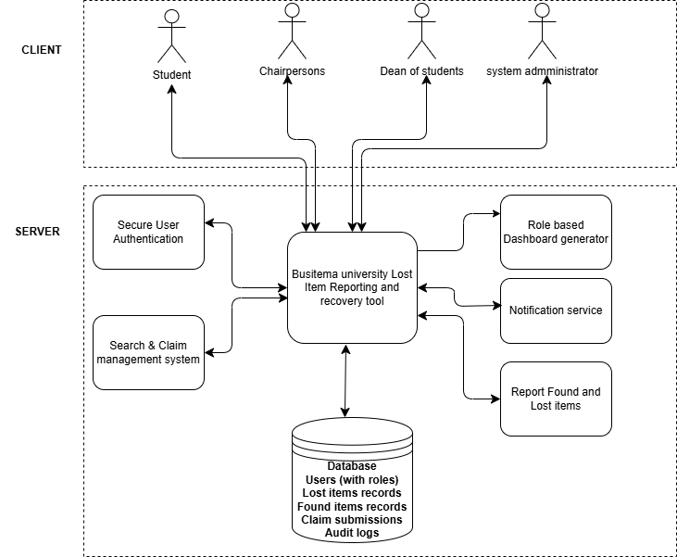
Figure 1:Architectural Design

4.6.2 System Context Diagram
This is the highest level of Data Flow Diagram that defines the scope of the system and provides an "outward" looking view from the system, showing system boundaries and interaction with external entities. The Context Diagram also shows other subsystems or groups of people that interact with the system and the main flows of data.
Entities and Their Interactions
External Entities:
- Student/Staff User
Input Flows: Registration details, login credentials, lost item reports, found item reports, claim requests, search queries, messages.
Output Flows: Login confirmation, search results, claim status updates, notifications, messages from other users.
- Student leader eg Chairperson (Resident/Non-Resident)
Input Flows: Login credentials, review decisions (verify/approve/reject), claim verification inputs, escalation triggers.
Output Flows: Dashboard views of assigned items, verification requests to users, escalated cases to Dean.
- Dean of Students
Input Flows: Login credentials, final approval decisions, dispute resolution inputs.
Output Flows: Dashboard view of escalated cases, final verdict notifications.
- System Administrator
Input Flows: Login credentials, role assignments, system configuration settings, override commands.
Output Flows: System logs, audit trails, user management interface.

CONTEXT DIAGRAM SHOWING THE WEB BASED RECOVERY TOOL
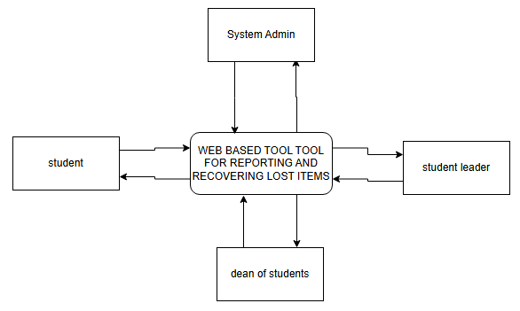
Figure 2: Context Diagram

4.6.3 Data Flow Diagram (DFD)
Data Flow Diagram shows how data moves or changes through a specified sequence in a graphical top-down fashion that describes the system components, processes, and interfaces. It helps to examine the Inputs, Outputs, and Processes of the Lost Item Reporting and Recovery System.
Flow of processes
Flow 1: User Registration and Login (P1)
- User submits registration data → P1 validates and stores data in D1 (User Profiles).
- P1 sends confirmation back to User.
- For login, User submits credentials → P1 checks against D1 → grants access token with appropriate role.
Flow 2: Reporting an Item (P2)
- User submits item details (lost/found) with description and photo → P2 receives the data.
- P2 validates the input and stores the record in either D2 (Lost Items) or D3 (Found Items).
- P2 triggers P5 (Notification Service) to send a confirmation to the User.
- P2 also makes the item visible in search results for other users.
Flow 3: Searching for Items (P2)
- User submits search criteria (keywords, category) → P2 queries D2 and D3.
- P2 returns matching results to User.
Flow 4: Claiming a Found Item (P3)
- User (Loser) submits a claim on a found item with proof of ownership → P3 creates a new claim record in D4 (Claims) with status "Pending".
- P3 triggers P5 to notify the relevant Chairperson of a new claim requiring review.
- P3 also updates the status of the item in D3 to "Claimed - Pending Verification".
Flow 5: Claim Verification by Chairperson (P3)
- Chairperson logs in and retrieves pending claims from D4 via P3.
- Chairperson reviews the claim and the item details.
- If Standard Item:
Chairperson approves → P3 updates D4 status to "Approved".
P3 updates the item status in D3 to "Returned".
P3 triggers P5 to notify the User (Loser) and the User (Finder).
- If High-Value or Disputed Item:
Chairperson escalates → P3 updates D4 status to "Escalated".
P3 passes the case to P4 (Escalation Management) .
Flow 6: Escalation Management (P4)
- P4 receives the escalated case from P3.
- P4 retrieves full details from D2/D3 and D4.
- P4 assigns the case to the Dean of Students via their dashboard.
- P5 sends a notification to the Dean about the new escalated case.
Flow 7: Final Approval by Dean (P4)
- Dean logs in and reviews the escalated case via P4.
- Dean makes a final decision (Approve/Reject).
- P4 sends the decision back to P3.
- P3 updates D4 with the final status.
- P5 notifies all relevant parties (User Loser, User Finder, and Chairperson).
Flow 8: Administrative Functions (P6)
- System Admin logs in and accesses P6.
- P6 allows the Admin to assign roles (e.g., change a User to Chairperson) and update D1.
- P6 allows the Admin to view D5 (Audit Logs) for monitoring.
- P6 logs all admin actions back to D5
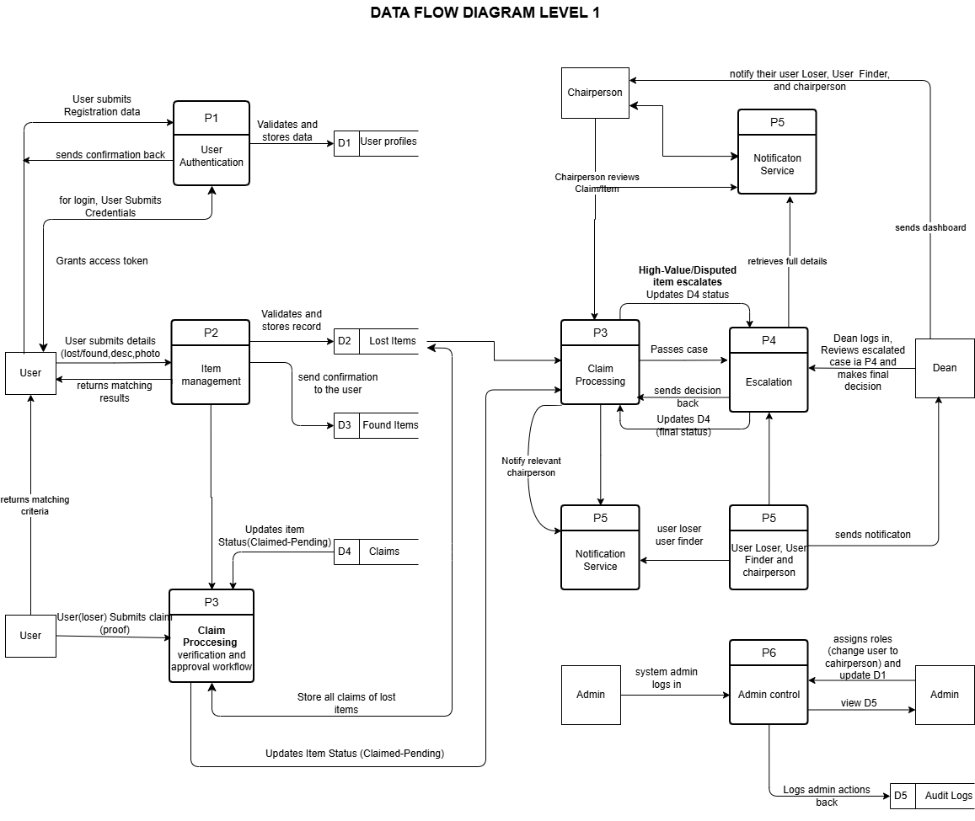
Figure 3: Data Flow Diagram

4.6.4 Use Case Diagram
The Use Case diagram represents the activities of the users with special functionalities of the system. Use Case Diagram model shows what the system is expected to do and to view externally the use of the system from the user's perspective rather than internally.
Actors and their Use Cases:
Student/Staff User: Register, Login, Report Lost/Found, Search, Submit Claim, Track Status, Send Messages
Chairperson: Login, View Dashboard, Review Reports, Verify Claims, Approve Standard Items, Escalate Cases
Dean: Login, View Escalated Cases, Review Claims, Provide Final Approval, Resolve Disputes
System Admin: Login, Manage Roles, Configure System, Monitor Logs, Override Records
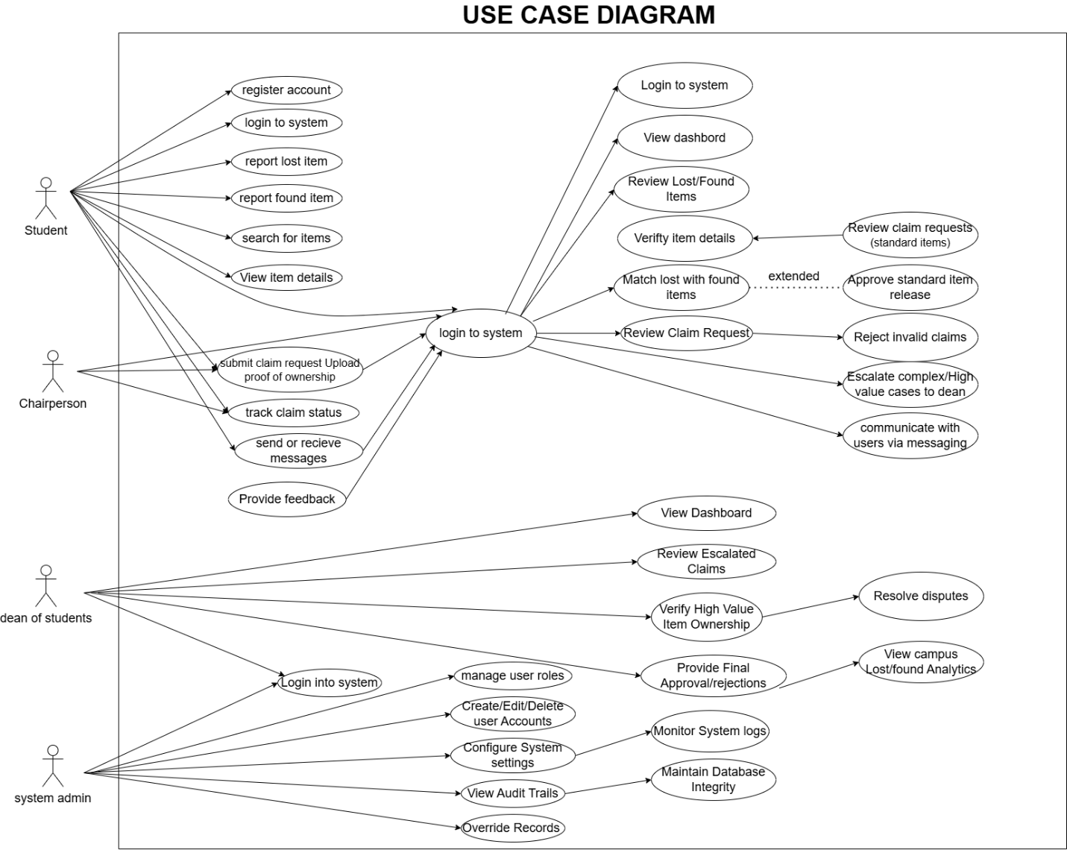
Figure 4:Use Case diagram

4.6.5 Sequence Diagram
The Sequence Diagram shows the interaction between objects over time for claiming and approving a found item (standard case). Participants include User Loser, User Finder, System, Chairperson, and Database.
Sequence Diagram for the Web Based recovery tool
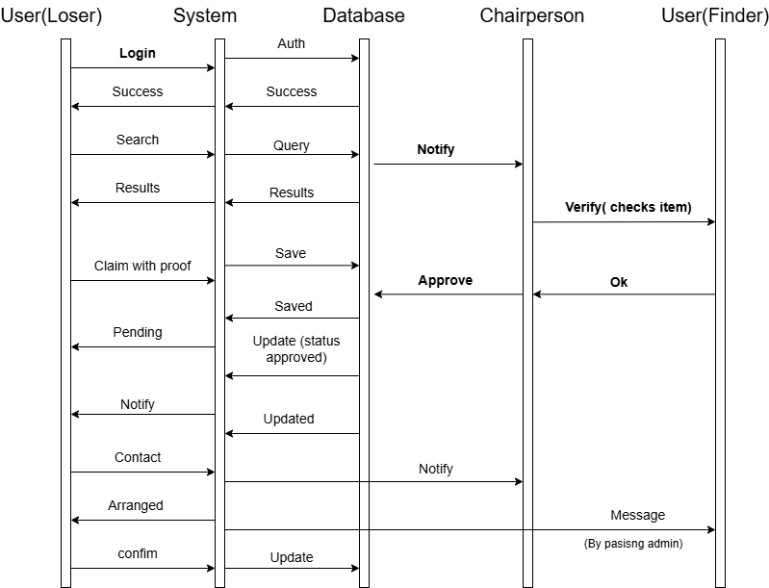
Figure 5:sequence Diagram

4.6.6 Entity Relationship Diagram (ERD)
The Entity Relationships diagram is a graphical representation of the relationship between the entities and attributes with in a proposed database of the system. The entities include: User, Lost item, Found Item, Claim, Escalation, Message, and Audit Log

THE ENTITY RELATIONSHIP DIAGRAM SHOWING THE SYSTEM
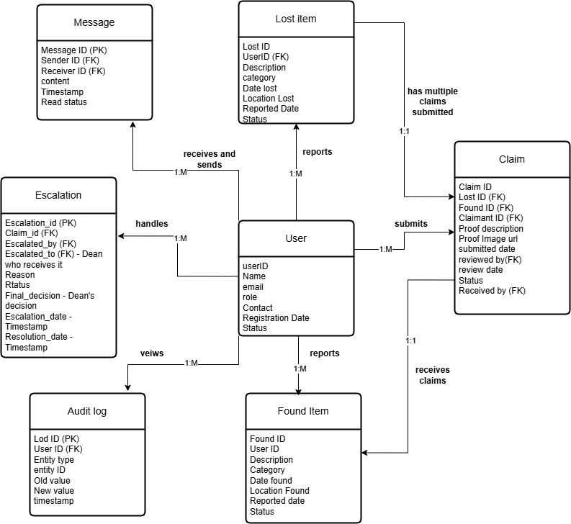
Figure 6:Entity Relationship Diagram
Entities
User Entity: This is the central entity of the database. It stores all information about individuals who have registered to use the system. Each user record contains a unique user identifier that serves as the primary key, the user's full name, email address, phone number, a hashed password for secure authentication, the user's role (Student, Chairperson, Dean of Students, or System Administrator), and a timestamp indicating when the account was created. The User entity serves as the foundation for all other entities, as every lost item, found item, claim, escalation, and message must be linked to a valid user.
Lost Item Entity: This entity stores every report of a lost item submitted by users. Each lost item record contains a unique lost item identifier as its primary key, a foreign key referencing the user who reported the item, the title of the item, a detailed description, the category of the item (such as Electronics, Documents, Accessories, Books, or Personal Items), the date the item was lost, the specific location on campus where it was lost, an optional path to an uploaded photograph, and the current status of the report (Active, Matched, or Closed).
Found Item Entity: This entity stores every report of a found item submitted by users. The structure closely mirrors the Lost Item entity. Each found item record contains a unique found item identifier as its primary key, a foreign key referencing the user who reported finding the item, the title and description of the item, its category, the date and location where it was found, an optional photo path, and the current status (Active, Claimed, or Returned).
Claim Entity: This entity tracks every ownership claim submitted by a user against a found item. Each claim record contains a unique claim identifier as its primary key, a foreign key referencing the lost item being claimed (when applicable), a foreign key referencing the found item being claimed, a foreign key referencing the claimant user, the proof of ownership provided by the claimant (which may be a receipt photo, serial number, or descriptive evidence), the current status of the claim (Pending, Under Review, Approved, Rejected, or Escalated), and timestamps for when the claim was created and when it was resolved.
Escalation Entity: This entity manages claims that have been forwarded from Chairpersons to the Dean of Students for final resolution. Each escalation record contains a unique escalation identifier as its primary key, a foreign key referencing the claim being escalated, a foreign key referencing the Chairperson who initiated the escalation, a foreign key referencing the Dean assigned to review the case, a text field explaining the reason for escalation, the current status of the escalation, and a timestamp indicating when the case was resolved.
Audit Log Entity: This entity records all critical actions for security and accountability purposes. Each audit log record contains a unique log identifier as its primary key, a foreign key referencing the user who performed the action, a description of the action taken (such as "User logged in," "Claim approved," or "Role changed"), a timestamp of when the action occurred, and the IP address from which the action originated.
Message Entity: This entity facilitates communication between users and administrators. Each message record contains a unique message identifier as its primary key, foreign keys referencing both the sender and the receiver of the message, the content of the message, a timestamp of when the message was sent, and a boolean flag indicating whether the message has been read by the recipient.
2. Relationships
User to Lost Item (One-to-Many): One user can report many lost items over time. For example, a student who loses their phone in the library on Monday and their wallet in the cafeteria on Wednesday creates two separate lost item records, both linked to the same user identifier. Conversely, each lost item belongs to exactly one user.
User to Found Item (One-to-Many): One user can report many found items. A helpful student who finds a laptop in a lecture hall and later finds a water bottle in the sports field creates two found item records linked to their account. Each found item belongs to exactly one user.
User to Claim as Claimant (One-to-Many): One user can submit many claims over time. A student who loses their ID card and later loses their phone might submit separate claims for each item when they are found. Each claim belongs to exactly one claimant user.
User to Claim as Approver (Chairperson) (One-to-Many): One Chairperson can review and approve many claims during their tenure. A Chairperson might verify twenty claims in a single week. However, each claim is reviewed by exactly one Chairperson at the operational level.
User to Escalation as Dean (One-to-Many): One Dean can handle many escalated cases. The Dean of Students might resolve five disputed claims per month. Each escalation is assigned to exactly one Dean for final resolution.
Lost Item to Claim (One-to-Many): One lost item can have multiple claims submitted against it. For example, if two different students claim the same found laptop, both claims will reference the same lost item. This supports resolution of ownership disputes.
Found Item to Claim (One-to-Many): Similarly, one found item can receive multiple claims from different potential owners. A found phone might be claimed by three different students. The system tracks all claims against the same found item.
Claim to Escalation (One-to-One, Optional): A claim may be escalated at most once. Only claims that are disputed, involve high-value items, or cannot be resolved at the Chairperson level proceed to escalation. Many claims are approved or rejected at the Chairperson level and never require escalation. This is an optional relationship.
User to Message Sender (One-to-Many): One user can send many messages to administrators. A student with questions about their claim might send multiple messages as the claim progresses. Each message has exactly one sender.
User to Message Receiver (One-to-Many): One user can receive many messages. An administrator managing multiple claims might receive messages from dozens of students. Each message has exactly one receiver.

CHAPTER FIVE

IMPLEMEMTATION AND TESTING

5.1 Introduction
This chapter presents the implementation and testing of the system and shows login interfaces which give authentication of users to provide security to unauthorized users, allows registration of new users, role-based dashboards, and testing of the system.
Implementation involves turning an idea from concept to reality. According to the system design described earlier, the lost item reporting and recovery system website, consisting of two major parts (the backend and the frontend), was successfully implemented. At the developing stage, where enough research and experiments were done among the programs and databases, the major software that were used include PHP, MYSQL, Xampp, HTML, CSS, Bootstrap, and JavaScript that were so important in the development of the entire system with its databases.

5.2 Login Interface Design
The login interface for users gives a clear distinction between different user roles. Given the fact that different users have different permissions, the system authenticates each user and directs them to their respective dashboard based on their assigned role (Student, Chairperson, Dean, or Admin).
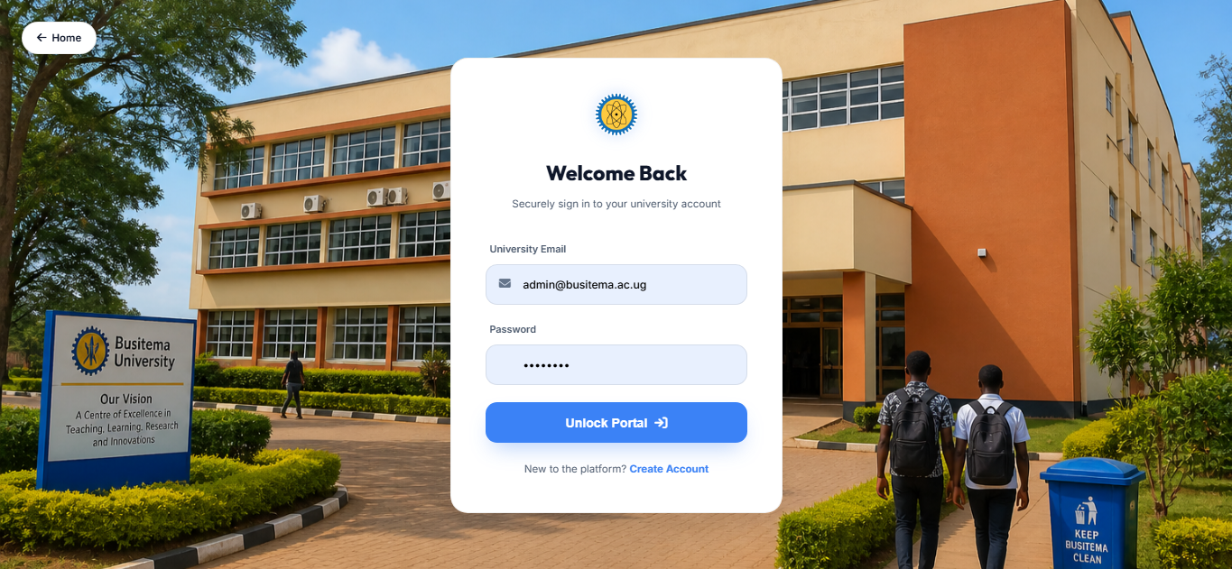
Figure 7:Login Interface Design

5.3 User Registration Interface
The registration interface enables new users to create an account in the system. Users provide their name, university email, phone number, and create a password. The system validates the email domain to ensure only Busitema University users can register.
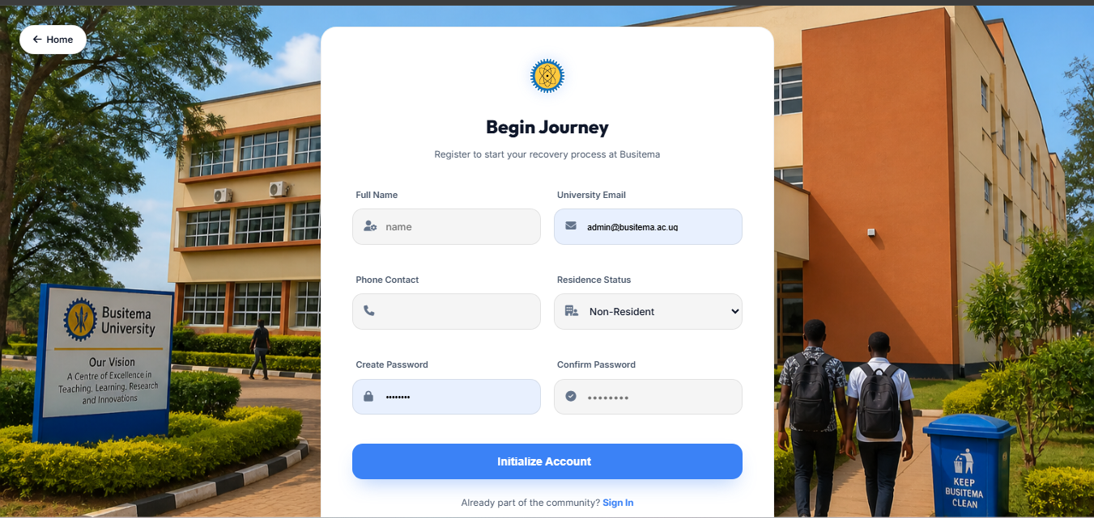
Figure 8: User Registration Interface

5.4 Admin User Management Interface
The Admin user management interface gives a clear way of managing users. Given the fact that the admin has the overall technical authority over the system, they can create accounts for new users, assign roles (Student, Chairperson Resident, Chairperson Non-Resident, Dean, Admin), edit user details, suspend accounts, and view audit logs.
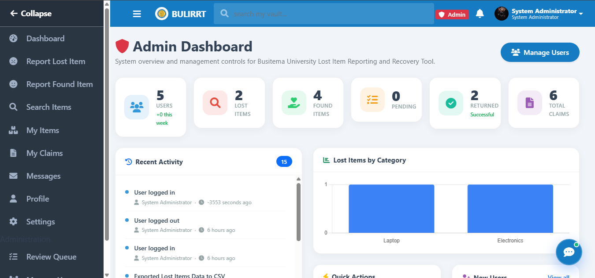
Figure 9:Admin User Management Interface

5.5 Report Lost Item Interface
The interface enables users to capture the details of a lost item into the system. Users provide the title, description, category, date lost, location lost, and can upload a photo of the item. This makes it more efficient and faster to retrieve information about lost items at a later time than the manual current system.
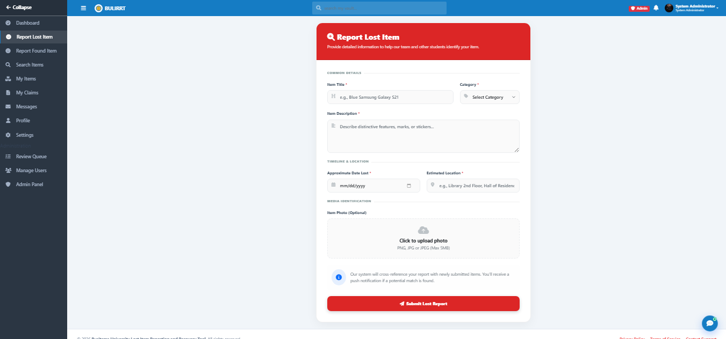
Figure 10:Report Lost Item Interface

5.6 Report Found Item Interface
The interface enables users to capture the details of a found item into the system. Users provide the title, description, category, date found, location found, and can upload a photo of the item. The system then makes this information available for others searching for their lost items.
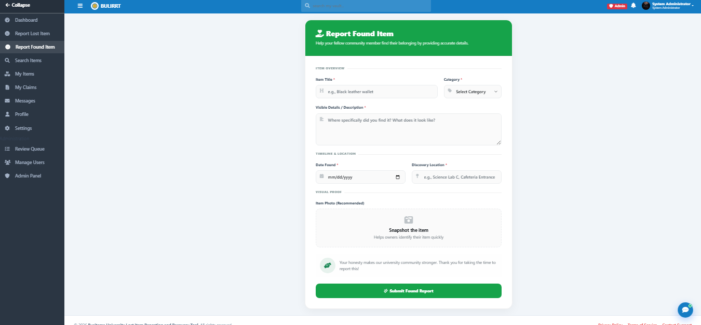
Figure 11:Report Found Item Interface

5.7 Dashboard Interface for Chairperson
The Chairperson dashboard provides an overview of all pending claims, newly reported items, and assigned tasks. Chairpersons can review claims, verify item details, match lost with found items, approve standard item releases, and escalate complex cases to the Dean.
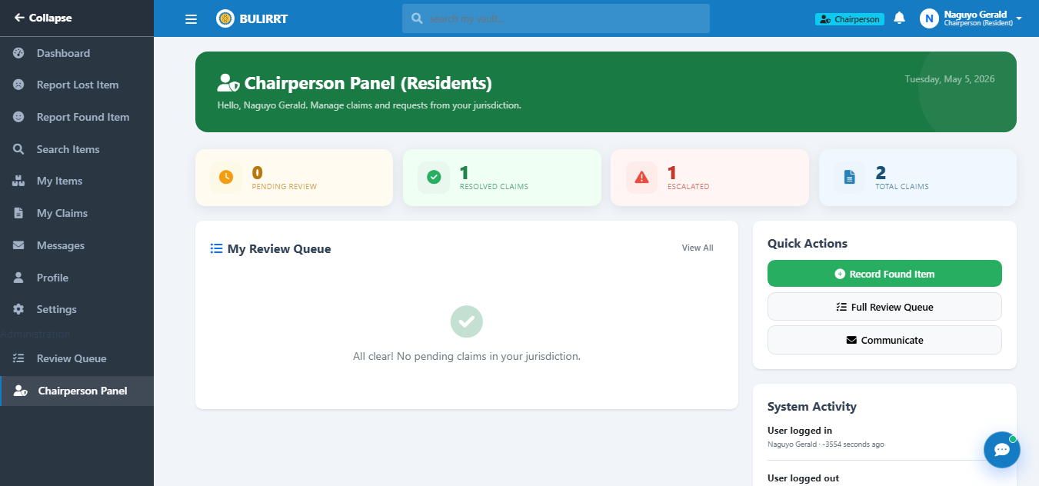
Figure 12:Dashboard Interface for Chairperson

5.8 Dashboard Interface for Dean
The Dean dashboard provides an overview of all escalated cases and high-value claims requiring final approval. The Dean can review escalated claims, verify ownership evidence, provide final approval or rejection, resolve disputes, and view campus-wide analytics on lost and found trends.
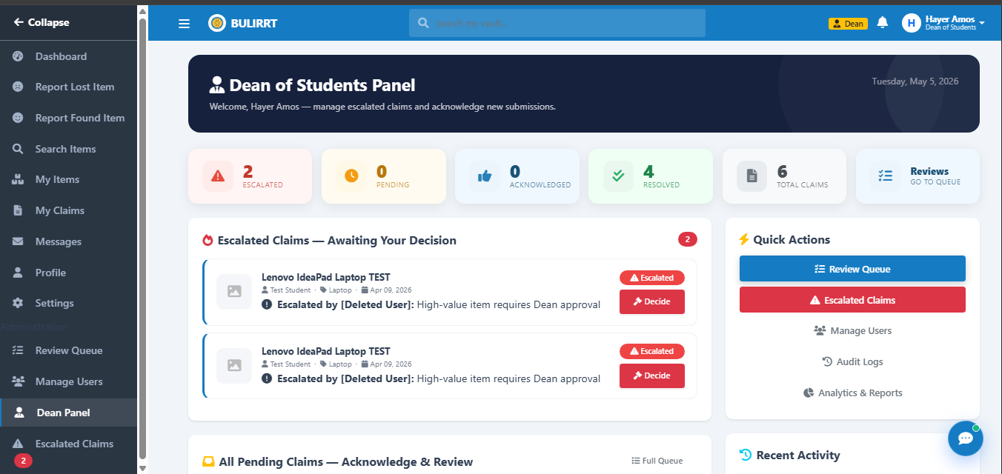
Figure 13:Dashboard Interface for Dean

5.9 Claim Management Interface
The claim management interface allows users to submit claims for found items with proof of ownership. Users can upload images of receipts, serial numbers, or other identifying information. The interface also shows the real-time status of submitted claims (Pending, Under Review, Approved, Rejected, Escalated).
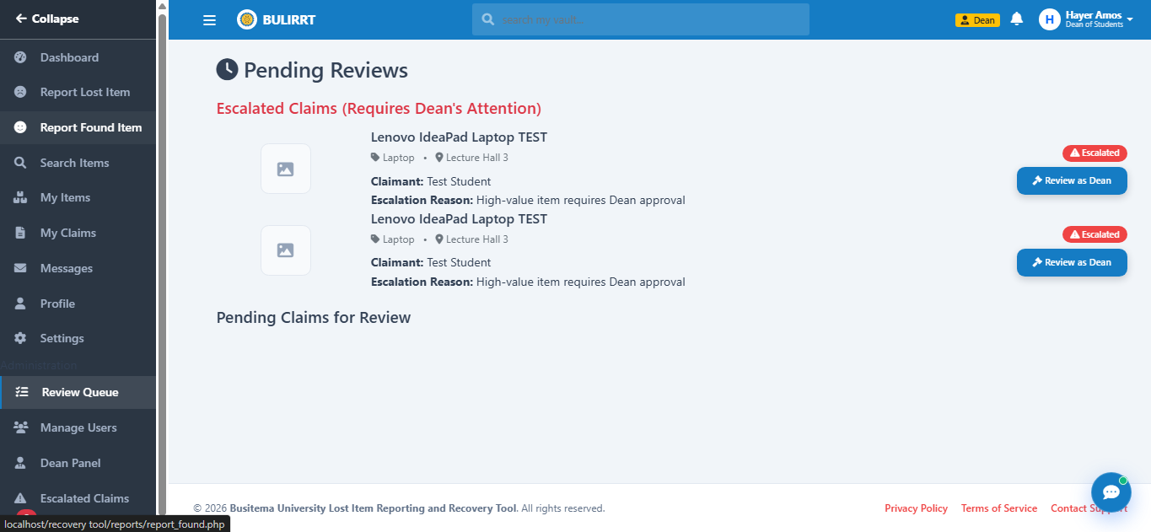
Figure 14: Claim Management Interface

5.10 Escalation Management Interface
The escalation management interface allows Chairpersons to escalate complex or high-value cases to the Dean. Chairpersons provide a reason for escalation, and the system automatically notifies the Dean. The Dean can then review the case and provide a final decision.
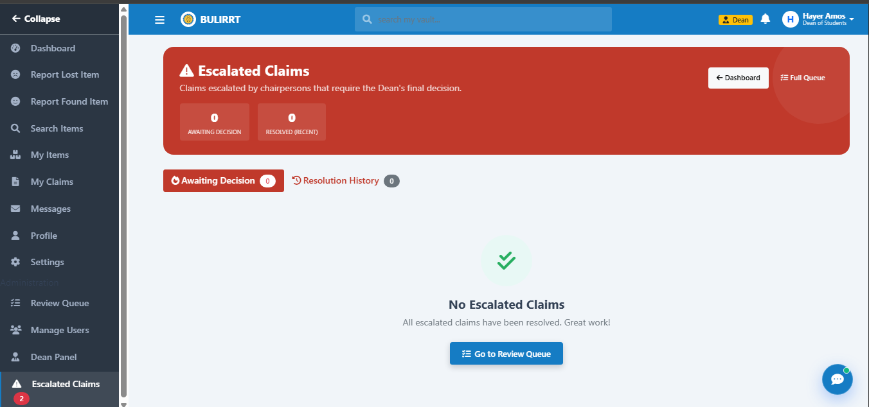
Figure 15:Escalation Management Interface

5.11 System Testing
System testing is a technique used to evaluate the system; it is focused on how the users interact with the front end of the system. In order to discover the weaknesses and strengths of the system, the following testing strategies were used.

5.11.1 Unit Testing
This is a method where individual units of source code are tested to determine if they are ready for use. A unit is the smallest testable part of an application. The system was tested unit by unit with the presence of the supervisor in order to enable the developer to identify each part of the program and show that individual parts function correctly.

5.11.2 Integration Testing
The various components of the system were meaningfully manipulated. This tested the general functionality of the system as a whole after unit-by-unit testing. The integration between the reporting module and the claim verification module, as well as between the escalation module and the Dean's dashboard, was tested successfully.

5.11.3 Security Testing
Incorrect usernames and passwords which did not exist in the database were used to access the system, but all attempts were unsuccessful, meaning our authentication procedure was perfected. Role-based access control was tested by attempting to access admin functions with a student account, which was properly blocked.

5.11.4 User Acceptance Testing
End users including students, Chairpersons, and the Dean of Students simulated real-world scenarios to verify whether the system meets functional requirements. Feedback was collected and used to fine-tune the system before final deployment.

CHAPTER SIX

DISCUSSION, CONCLUSIONS, RECOMMENDATIONS AND FUTURE WORK

6.1 Introduction
This chapter summarizes the project, identifying what was achieved in the set objectives. It also recommends areas that need further attention and draws conclusions for the project findings.

6.2 Discussion of Results
The study managed to achieve the four main objectives of the project that generated the themes: requirements determination, system design, implementation, and system testing. The study resulted in the development of the web-based lost item reporting and recovery system through the following:

6.2.1 Determination of System Requirements
The requirements of the study were obtained from two main sources: literature review and field research. Under literature review, the study examined previous projects on similar topics, including digital lost and found systems such as FindItHere (Murugiah & Mat Nawi, 2025), AUFound (Castro et al., 2021), and LostNet (Zhou et al., 2024). Studies by Tan and Chong (2023) confirmed that recovery rates using conventional methods remain below 40 to 50 percent. Research by Suchana et al. (2021) revealed that sharing personal contact information in public WhatsApp groups exposes users to privacy violations and harassment.
The field research, conducted through focus group discussions, interviews, and questionnaires administered to 20 participants (15 students, 3 Chairpersons, 1 Dean of Students, and 1 System Administrator) at Busitema University Nagongera Campus, helped establish how the current manual system operates and gathered respondents' views toward the proposed digital system. Key findings revealed that 90% of respondents have lost an item on campus, but only 30% successfully recovered it. The field research generated key requirements, including the need for secure user authentication, role-based access control, item reporting with photo uploads, claim submission with proof of ownership, and a four-level administrative control structure (Student, Chairperson, Dean of Students, System Administrator). Key functional requirements identified included user registration and login, lost and found item reporting, search functionality, claim management, and escalation management. Non-functional requirements included usability for users with varying digital literacy, security through password hashing and role-based access control, and accountability through comprehensive audit logging.

6.2.2 System Design
The system was designed based on the gathered requirements, following the Rapid Application Development (RAD) approach from Structured Systems Analysis and Design Methodology (SSADM) (Pressman, 2014; Sommerville, 2016). The design stage employed several modeling tools, including the System Architecture (three-tier client-server model), Context Diagram, Data Flow Diagram (DFD), Use Case Diagram, Sequence Diagram, and Entity Relationship Diagram (ERD), which facilitated smooth data flow throughout the system (Connolly & Begg, 2015).
The System Architecture adopted a three-tier client-server model, separating the user interface, processing logic, and data management to enhance security, maintainability, and scalability (Murugiah & Mat Nawi, 2025). The client tier (frontend) was built using HTML, CSS, Bootstrap, and JavaScript, providing separate interfaces for students and administrators. Bootstrap ensured a responsive, mobile-friendly interface as recommended by Castro et al. (2021).
The application server tier (backend) was built using PHP, handling user authentication, role-based access control, claim processing, and escalation management (Murugiah & Mat Nawi, 2025). The database server tier used MySQL, storing user profiles, lost and found items, claims, escalations, messages, and audit logs (Connolly & Begg, 2015). The audit logging functionality ensures accountability and provides a dispute resolution trail, as emphasized by Florida A&M University (2019) and UMBPD (n.d.).
The Database Schema and Entity Relationship Diagram defined tables for Users, Lost Items, Found Items, Claims, Escalations, Messages, and Audit Logs, with appropriate primary key and foreign key relationships to maintain data integrity (Connolly & Begg, 2015).

6.2.3 System Implementation
The system was implemented using Visual Studio Code as the primary code editor, XAMPP server for local development, PHP for backend development, MySQL for database management, and HTML, CSS, Bootstrap, and JavaScript for frontend development (Murugiah & Mat Nawi, 2025; Castro et al., 2021). XAMPP provided a complete local web server environment that simplified setup (Connolly & Begg, 2015).
The implementation produced the interfaces shown in Chapter Five, including login, registration, admin user management, report lost/found item interfaces, Chairperson and Dean dashboards, claim management, and escalation management interfaces. The login and registration interfaces implemented secure user authentication with password hashing (Michail, 2025; Wadho et al., 2023). Role-based access control ensured users could only access functions appropriate to their assigned role (Student, Chairperson, Dean, or Admin) (Surve, Sarkare, & Kadam, 2026).
The Chairperson and Dean dashboards provided the multi-level administrative control structure with clear separation of duties and formal escalation pathways for high-value claims (Florida A&M University, 2019; Penn State University, 2020). The system was designed to be responsive on both desktop and mobile devices using the Bootstrap framework (Jiang, Mao, & Kang, 2019; Poojitha et al., 2026).

6.2.4 System Testing
The system was tested using multiple strategies. According to Pressman (2014), software testing ensures the system meets its requirements and functions correctly.
Unit testing verified individual modules, including item reporting, user registration, role assignment, and escalation triggers, each tested separately to ensure correctness (Pressman, 2014).
Integration testing ensured that all modules worked together seamlessly, verifying data flow between the reporting and claim verification modules and between different administrative levels (Sommerville, 2016).
Security testing confirmed that incorrect login credentials could not access the system and that role-based access control properly blocked unauthorized actions (Michail, 2025; Wadho et al., 2023).
User Acceptance Testing (UAT) involved end users (students, Chairpersons, Dean of Students, and System Administrator) simulating real-world scenarios to verify functionality and usability (Castro et al., 2021; Murugiah & Mat Nawi, 2025). Feedback from UAT was used to fine-tune the system before deployment. As presented in Chapter Five, the validation results confirmed that the system met user expectations with an overall average score of 4.12 out of 5 (82.4%) .

6.3 Conclusion
Basing on the findings of the study, it was established that Busitema University Nagongera Campus has a significant problem with lost items and low recovery rates. The use of ICT resources like computers and the internet for lost item management is lacking, thus leading to inefficient support for users and staff to manage lost and found items effectively. This therefore requires Busitema University Nagongera Campus to adopt a computerized web-based system which is digitalized, other than managing lost item reporting and recovery manually, for the success of the system and to enjoy various advantages of ICT software.

6.4 Recommendations
- Adoption by the University: I recommend that my web-based lost item reporting and recovery system be adopted by Busitema University Nagongera Campus to replace the current fragmented manual system, thereby improving recovery rates and reducing student stress and financial loss.
- Training for Users: I recommend that the university provides basic training for both staff (Chairpersons, Dean of Students, System Administrator) and students on how to use the computerized system effectively to ensure maximum adoption and proper utilization.
- Integration with University Systems: I recommend that the system be integrated with the university's existing student information system to automatically verify student identities and streamline the claim verification process for ID cards and other university-issued items.
- Expansion to Other Campuses: I recommend that the system be expanded to other Busitema University campuses (Busitema, Namasagali, Pallisa, and Mbale) to create a unified lost and found management platform across the entire university.
- Future studies to be done : Basing on this research

6.5 Limitations and Future Work
- The system was evaluated solely at Nagongera Campus with a small sample of 20 participants; therefore, further testing should be conducted across other Busitema University campuses (Busitema, Namasagali, Pallisa, and Mbale) to validate its effectiveness across diverse student populations and administrative frameworks.
- The system depends on Chairpersons to manually match lost and found items, which is a labor-intensive process; therefore, machine learning algorithms should be implemented to automate item matching based on descriptions, categories, and uploaded images, thereby reducing manual effort and enhancing recovery rates.
- The system currently sends notifications only via email, which may not reach students who lack regular email access; therefore, SMS notifications and USSD-based reporting should be integrated to ensure that all students, regardless of their phone type, can receive updates and report items.
- The system has not been deployed on a public server, which restricts its security, uptime, and accessibility; therefore, the system should be hosted on a commercial web-hosting platform such as AWS or Google Cloud to guarantee 24/7 availability and enhanced security.
- QR code-based item tagging was not incorporated into the present version; therefore, QR code tagging should be introduced to facilitate easier identification and return of valuable possessions such as laptops, mobile phones, and university ID cards.

REFERENCES
Abbad, M. M. M. (2021). Using the UTAUT model to understand students' usage of e-learning systems in developing countries. Education and Information Technologies, 26(6), 7205-7224.
Al-Galal, H. Q. A. M. (2023). Building a web-based e-learning information system in Universitas Trunojoyo Madura using the waterfall method (Undergraduate thesis). Universitas Narotama.
Bienvenu, T. (2025). AI-driven lost and found management system for institutions. Strathmore University.
Bliemel, M., Mery Keitel, A., & Key, T. (in press). Lost and found: Intensive remote learning. In K. Carruthers & S. Griffiths (Eds.), Education in the age of corona: Pandemic pivots and productive portals. Common Ground Research Networks.
Castro, E., David, K., De Silva, K., Roxas, L., & Macaspac, J. (2021). AUFound: Retrieval of misplaced personal belongings through mobile application and web-based management system designed for Angeles University Foundation. Proceedings of the 12th International Conference on Industrial Engineering and Operations Management.
Data Ladder. (2026). Fuzzy matching 101: The complete guide to accurate data matching.
David, N. M., Catapang, G. M., Pabilando, K. P. V., Dala, L. T., Marcos, R. F., & Lacasandile, A. D. (2024). A comparative study on lost and found management systems in academic institutions. Proceedings of the 2024 6th International Workshop on Artificial Intelligence and Education (WAIE).
Dhawal, S. K., Barai, N. K., Jha, A. K., Prachi, A., & Ramchandani, S. M. (2025). LostLink - Lost anywhere find here. International Journal of Innovative Research in Science, Engineering and Technology (IJIRSET).
Florida A&M University. (2019). *University policy number: UP-01-02 internal controls and enterprise risk management authority*.
Jaspin, K., Kaviya, D., & Jane Afra. (2026). AI based lost and found system. Proceedings of the 2026 International Conference on Emerging Smart Computing and Informatics (ESCI).
Jiang, L., Mao, H., & Kang, Z. (2019). The design of campus lost and found platform based on digital map data. Proceedings of the 2019 International Conference on Computer Information Analytics and Intelligent Systems (CIAIS 2019).
Lasagas, K. P., Daig, C. S., Pabatang, I. J. M., Sumaylo, J. M., & Caw-it, J. G. (2025). USTP-Panaon lost and found management system. Proceedings of the 4th MDP Student Conference (MSC) 2025.
Michail, M. (2025). Photovoltaic company management system (Master's thesis). Cyprus University of Technology.
Murugiah, V., & Mat Nawi, R. (2025). FindItHere: Lost and found item matching web application. Applied Information Technology and Computer Science, 6(1), 207-216.
Operartis. (n.d.). A starter guide to using machine learning for reconciliations.
Pede, D., Ranawat, V., Shete, R., Gole, S., & Kolhe, T. (2025). Lost and found web application. International Journal of Innovative Science and Research Technology.
Penn State University. (2020). Procedure AD2001 lost and found items. GURU.
Poojitha, P., Prithvi, B. M., Priyanka, J. B., & Prathana, M. O. (2026). Smart lost and found system for campus. International Journal of Research in Engineering & Science (IJRES).
Pressman, R. S. (2014). Software engineering: A practitioner's approach (8th ed.). McGraw-Hill Education.
Raut, A. B., Mali, S., Malkunak, D., Mandhane, R., Mandke, N., & Wanjale, K. (2026). Lost and found campus portal. Proceedings of the 2026 International Conference on Emerging Trends and Innovations in ICT (ICE).
Salha, Z., & Pal, B. L. (2025). "Mewar lost and found information system". International Journal of Computer Science Engineering Techniques, 9(6), 1-13.
Saunders, M. N. K., Lewis, P., & Thornhill, A. (2023). Research methods for business students (9th ed.). Pearson.
Sergeeva, O. V., Zheltukhina, M. R., Shoustikova, T., Tukhvatullina, L. R., Dobrokhotov, D. A., & Kondrashev, S. V. (2025). Understanding higher education students' adoption of generative AI technologies: An empirical investigation using UTAUT2. Contemporary Educational Technology.
Shahzan, N. F., & Arbaiy, N. (2025). UTHM lost and found management system. Applied Information Technology and Computer Science (AITCS).
Sharkey, J. (2013). ChargerBack: A cloud-based lost and found solution. Hospitality Technology Review, 8(3), 45-52.
Slashdot Media. (2023). iLost for Business: Enterprise lost and found management. Software Reviews, 12(2), 34-40.
Sommerville, I. (2016). Software engineering (10th ed.). Pearson Education.
Srilatha, D., Bhanu, S. U., Lalith, Y., Sadik, S. A., & Ganesh, K. K. (2026). Smartlofo: AI powered lost and found platform. International Journal of Scientific Research and Engineering Trends.
Suchana, K., Alam, S. M. E., Meem, A. T., Turjo, M. D., & Khan, M. M. (2021). Development of user-friendly web-based lost and found system. Journal of Software Engineering and Applications, 14(10), 575-590.
Surve, P., Sarkare, S., & Kadam, P. (2026). Campus connect. Journal of Emerging Technologies and Innovative Research (JETIR), 13(3), 1-6.
T, Abhiram, Ashok Krishnan, E. B., Manjith, K. M., Vishnu, A. P., & Ambarish, A. (2024). CampusTrace - Application for lost and found items on campus. Journal of Trends in Computer Science and Smart Technology.
Tan, S. Y., & Chong, C. R. (2023). An effective lost and found system in university campus. Journal Information and Technology Management (JISTM).
UMBPD (University of Maryland, Baltimore Police Department). (n.d.). Policy 802: Property. University of Maryland, Baltimore.
University of Alabama Museums. (2020). Collections management policy.
Wadbudhe, R., Ganesh, V., Patil, A., Meshram, A., Sayyed, A., & Hedau, A. (2025). Uni Find: Lost and found objects management system for campus using AI & cloud services. IJLTEMAS.
Wadho, S. A., Meghji, A. F., Yichient, A., Kumar, R., & Shaikh, F. B. (2023). Encryption techniques and algorithms to combat cyber-attacks: A review. Journal of Information & Communication Technology.
Zhou, M., Fung, I., Yang, L., Wan, N., Di, K., & Wang, T. (2024). LostNet: A smart way for lost and find. PLoS ONE, 19(10), e0310998

APPENDICES

Appendix i: Interview Guide For Requirements Gathering
Topic: Web-Based Tool for Reporting and Recovering Lost Items
Target Respondents: Students, Chairpersons, Dean of Students
Questions for Students:
- Have you ever lost an item on campus? If yes, what item and what did you do?
- How satisfied are you with the current lost and found methods (notice boards, WhatsApp groups)?
- What challenges have you faced when trying to recover a lost item?
- What features would you want in a digital lost item reporting system?
- Do you have a smartphone and regular internet access?
- Would you be comfortable reporting lost items online with your contact information?
Questions for Chairpersons/Dean of Students:
- How are lost items currently managed in your area of responsibility?
- What challenges do you face with the current system?
- How many lost item reports do you receive per week on average?
- What is the approximate recovery rate for lost items?
- What verification methods do you currently use to confirm ownership?
- How do you handle disputes when two people claim the same item?
- What features would you need in a digital system to manage lost items effectively?

Appendix ii: Questionnaire For Requirements Gathering
Topic: Lost Item Reporting and Recovery System Requirements
Dear Respondent, This questionnaire aims to gather requirements for developing a web-based lost item reporting and recovery system at Busitema University Nagongera Campus. All responses will be confidential and used only for academic purposes.
Section A: Demographic Information
- Status: ☐Student ☐Chairperson ☐Dean of Students ☐Staff
- Year of Study (if student): ☐Year 1 ☐Year 2 ☐Year 3
- Gender: ☐Male ☐Female
Section B: Experience with Lost Items
- Have you ever lost an item on campus? ☐Yes ☐No
- If yes, what type of item? ☐Phone ☐Laptop ☐ID Card ☐Wallet ☐Keys ☐Textbook ☐Other: __________
- Were you able to recover the item? ☐Yes ☐No
- If you lost an item and either recovered it or not, please briefly describe what happened. (e.g., Where did you lose it? How long did it take? What went well or went wrong?)

Section C: Current System Evaluation
- What method did you use to report your lost item? ☐Notice board ☐WhatsApp group ☐Word of mouth ☐Reported to Chairperson ☐None
- On a scale of 1-5, how satisfied were you with the current method? (1=Very Unsatisfied, 5=Very Satisfied): _____
- What challenges did you face? (Select all that apply)
☐No one responded ☐Information got lost ☐Privacy concerns ☐No central place to check ☐Other: __________
- What was the most frustrating or difficult part of trying to recover a lost item using the current system?

Section D: Technology Access
- Do you own a smartphone? ☐ Yes ☐ No
- Do you have regular internet access? ☐Yes ☐No
- How often do you use the internet? ☐Daily ☐Weekly ☐Rarely ☐Never
Section E: Desired System Features
- Would you use a web-based system to report lost and found items? ☐Yes ☐No ☐Maybe
- What features would you find useful? (Select all that apply)
☐Report lost items with photo
☐Report found items with photo
☐Search for items
☐Submit claim with proof of ownership
☐Track claim status
☐Receive email/SMS notifications
☐Contact the person who found my item
- What concerns do you have about an online lost item system?
☐Privacy ☐Fake claims ☐Technical problems ☐None
- Do you have any other suggestions or comments that could help us design a better lost item recovery system for your campus?

Thank you for your participation!

