ELECTRONIC BOX FOR MULTI-CAMPUS SETTING
CASE STUDY: BUSITEMA UNIVERSITY

BY
BWENENE VICTORIA GRACE
REG.NO. BU/UP/2023/1631
A PROJECT REPORT SUBMITTED TO THE FACULTY OF SCIENCE AND EDUCATION FOR THE STUDY LEADING TO A PROJECT IN PARTIAL FULFILLMENT OF THE REQUIREMENTS FOR THE AWARD OF THE DEGREE OF BACHELOR OF SCIENCE IN EDUCATION OF BUSITEMA UNIVERSITY
Supervisor:
MR. OBOTH ANDREW
DEPARTMENT OF COMPUTER STUDIES
FACULTY OF SCIENCE AND EDUCATION, BUSITEMA UNIVERSITY

MAY, 2026




nySc

DEDICATION
Above all, I thank the Almighty God, whose grace, mercy, and faithfulness sustained me throughout every step of this academic journey. It is by His strength alone that I was able to begin, persevere, and complete this work. To Him be all the glory and honour.
This report is further dedicated to my beloved father, Mulede Francis Mugendala, and my dear mother, Kutolawo Betty Grace, whose unconditional love, sacrifice, and unwavering support have been my greatest source of strength and motivation. I also dedicate this work to my cherished siblings, Tino Lynda Clementine, Logose Mirembe Leticia, Bugonzi Gift Tabitha, and Kwagala Sheila, for their constant encouragement and the joy they bring to my life.
Finally, I extend a special dedication to my supervisor, Mr. Oboth Andrew, whose invaluable guidance, patience, and dedication to my growth as a researcher made the successful completion of this work possible.

ACKNOWLEDGEMENTS
All glory, honour, and praise belong to the Almighty God, the source of all wisdom and knowledge. I am deeply grateful for His grace that guided my steps, granted me understanding, and provided everything I needed to complete this project. Without Him, none of this would have been possible.
I extend my sincere and heartfelt gratitude to my supervisor, Mr. Oboth Andrew, for his dedicated guidance, constructive feedback, and continuous encouragement throughout the entire research and development process. His expertise and commitment to my academic growth were instrumental in shaping this work into what it is today.
I also wish to thank the lecturers of the Faculty of Science and Education at Busitema University for the knowledge, skills, and academic foundation they imparted throughout my course of study. Their commitment to quality education greatly informed the thinking and approach reflected in this project.
Finally, I am truly grateful to my dear friends Malinde Adongo Penninah, Nabirye Shivan and Azairwe Allan Kamangi, whose moral support, companionship, and belief in my abilities gave me the courage to push forward even in the most challenging moments of this journey. This achievement belongs to all of you.

TABLE OF CONTENT

DECLARATION i
APPROVAL ii
DEDICATION iii
ACKNOWLEDGEMENTS iv
TABLE OF CONTENT v
LIST OF TABLES ix
LIST OF FIGURES x
ABBREVIATIONS xi
ABSTRACT xii
CHAPTER ONE 1
1.0 Introduction 1
1.1 Background of the Study 1
1.2 Problem Statement 4
1.3 Main Objective 5
1.4 Specific Objectives 6
1.5 Significance of the Study 6
1.6 Project Scope 6
1.6.1 Geographical Scope 6
1.6.2 Content Scope 6
1.6.3 Technological Scope 6
CHAPTER TWO: 7
LITERATURE REVIEW 7
2.0 Introduction 7
2.1 Manual Suggestion Box Systems 7
2.2 Digital Suggestion Systems 8
2.3 Benefits and Challenges of Electronic Boxes for Multi-Campus Setting. 9
2.3.1 Benefits 9
2.3.2 Challenges 9
2.4 Related Studies 10
2.5 Gaps Identified in Existing Studies 12
CHAPTER THREE: 14
METHODOLOGY 14
3.0 Introduction 14
3.1 Area of Study 14
3.2 Sampling 14
3.3 System Development Methodology 15
3.3.1 Structured Systems Analysis and Design Methodology (SSADM) 15
3.4 Data Collection Tools 16
3.4.1 Interviews 16
3.4.2 Observation 16
3.4.3 Document and Literature Review 16
3.5 System Analysis 16
3.5.1 Microsoft Word 17
3.5.2 Microsoft Excel 17
3.5.3 SPSS (Statistical Package for the Social Sciences) 17
3.5.4 Epi Info 17
3.5.5 Draw.io / Lucid chart 17
3.5.6 Visual Paradigm 17
3.5.7 Google Forms 17
3.6 System Design Tools Used in Analysis 17
3.6.1 Context Diagrams 18
3.6.2 Data Flow Diagrams (DFDs) 18
3.6.3 Entity Relationship Diagram (ERD) 18
3.6.4 Use Case Diagrams 18
3.7 System Implementation 18
3.7.1 Development Environment and Technologies 18
3.7.2 Module Implementation 19
3.7.3 Database Implementation 19
3.8 Ethical Considerations 20
CHAPTER FOUR: 21
SYSTEM ANALYSIS AND DESIGN 21
4.0 Introduction 21
4.1 Analysis of the Current System 21
4.1.1 Strengths of the Current System 21
4.1.2 Weaknesses of the Current System 21
4.2 System Requirements 22
4.2.1 Functional Requirements 22
4.2.2 Non-Functional Requirements 22
4.3 Hardware and Software Requirements 23
4.3.1 Hardware Requirements 23
4.3.2 Software Requirements 23
4.4 System Development Approach 24
4.5 System Design 24
4.5.1 System Architecture 24
4.5.2 Database Design 25
4.5.3 Entity Relationship Diagram 25
4.5.4 Data Flow Diagram 26
4.5.5 Interface Design 27
4.5.6 Use Case Diagram 28
CHAPTER FIVE: 30
SYSTEM IMPLEMENTATION AND TESTING 30
5.0 Introduction 30
5.1 System Implementation 30
5.2 Interface Design 30
5.2.1 Login Interface 30
5.1.3 Registration Page 31
5.1.4 Student Dashboard and Suggestion Form 32
5.1.5 Feedback Tracking Interface 34
5.1.6 Administrator / HOD Dashboard 34
5.1.8 Report Page 35
5.3 System Testing 36
5.3.1 Unit Testing 36
5.3.2 Integration Testing 36
5.3.3 User Acceptance Testing (UAT) 36
5.3.4 Security Testing 37
CHAPTER SIX: 39
DISCUSSION, CONCLUSION, RECOMMENDATIONS, LIMITATIONS AND FUTURE WORK 39
6.0 Introduction 39
6.1 Discussion of Results 39
6.1.1 Objective 1: To review the literature and determine the requirements necessary to develop an electronic box for multi-campus setting. 39
6.1.2 Objective 2: To analyze data requirements and design the system. 39
6.1.3 Objective 3: To implement an electronic box for multi-campus setting. 40
6.1.4 Objective 4: To test and validate the functionality and efficiency of the electronic box for multi-campus setting. 40
6.2 Conclusion 40
6.3 Recommendations 41
6.4 Limitations 41
6.5 Future Work 42
REFERENCES 43
APPENDICES 45
APPENDIX 1: INTERVIEW GUIDING QUESTIONS 45
A For Students 45
B For Lecturers 45
C For Administrators 46

LIST OF TABLES
Table 2: Security Testing 47

LIST OF FIGURES
Figure 1: System Architecture 36
Figure 2: Entity Relationship Diagram 37
Figure 3: Data Flow Diagram 38
Figure 4: Use Case Diagram for suggestion box system 39
Figure 5: Login Interface 41
Figure 6: Registration Page 41
Figure 7: Student Dashboard and Suggestion Form 42
Figure 8: Student Dashboard and Suggestion Form 43
Figure 9: Feedback Tracking Interface 44
Figure 10: Administrator / HOD Dashboard 45
Figure 11: Report Page 46

ABBREVIATIONS
ICT Information and Communication Technology
SDG Sustainable Development Goals
SSADM Structured Systems Analysis and Design Methodology
SPSS Statistical Package for the Social Sciences
DFD Data Flow Diagram
ERD Entity Relationship Diagram
UAT User Acceptance Testing
PHP Hypertext Preprocessor
HTML / HTML5 HyperText Markup Language
CSS / CSS3 Cascading Style Sheets
MySQL My Structured Query Language
UPS Uninterruptible Power Supply
HOD Head of Department
NLP Natural Language Processing
API Application Programming Interface
QR Quick Response (code)
XSS Cross-Site Scripting
SQL Structured Query Language
SMS Short Message Service
RAM Random Access Memory
GHz Gigahertz
GB Gigabyte
iOS iPhone Operating System
HTTP HyperText Transfer Protocol
XAMPP Cross-Platform Apache MySQL PHP Perl

ABSTRACT
Effective feedback management is essential for promoting transparency, accountability, and participatory governance in higher education institutions. However, Busitema University, a public multi-campus university in Eastern Uganda, has continued to rely on manual physical suggestion boxes for collecting stakeholder feedback, a system characterized by delayed responses, loss of submissions, poor tracking mechanisms, and limited accessibility across geographically dispersed campuses. This study therefore sought to design and implement an Electronic Box for Multi-Campus Setting to address these persistent communication and feedback management challenges.
The study adopted the Structured Systems Analysis and Design Methodology (SSADM) as its development framework. Data was collected through structured interviews, direct observation, and document review involving students, lecturers, and administrative staff drawn from multiple campuses of Busitema University. The system was developed as a web-based application using PHP, HTML5, CSS3, JavaScript, Bootstrap, and MySQL as the database management system.
The implemented system provides a centralized digital platform through which students and staff can submit suggestions anonymously or with identification, track submission statuses in real time, and receive direct responses from campus administrators. An automated routing mechanism assigns submitted suggestions to the relevant campus administrator based on campus selection, while a reporting module enables administrators to generate analytics and summary reports to support data-driven decision-making.
System testing was conducted through unit testing, integration testing, user acceptance testing, and security testing, all of which confirmed that the system is functional, secure, accessible, and effective in improving institutional feedback management. The study concludes that the Electronic Box for Multi-Campus Setting successfully replaces the inefficient manual system with a transparent, inclusive, and scalable digital feedback platform capable of supporting communication across all campuses of Busitema University.

CHAPTER ONE

1.0 Introduction
This chapter presents the background of the study, the problem statement, the main and specific objectives, the significance of the study, and the scope within which the electronic box for multi-campus setting was developed and implemented at Busitema University.

1.1 Background of the Study
Effective communication between management and stakeholders is a critical component in the smooth operation, governance, and growth of organizations and institutions worldwide. Globally, institutions such as universities, corporations, and government agencies rely on efficient communication systems to ensure that opinions, complaints, recommendations, and innovative ideas from stakeholders are properly received, processed, and acted upon. Feedback systems enhance participatory management, transparency, accountability, and institutional responsiveness to stakeholder needs (Nwosu, 2020). Traditionally, organizations employed physical suggestion boxes as one of the simplest mechanisms for collecting anonymous feedback from employees, students, and clients. These systems were intended to encourage inclusivity by allowing individuals to freely express their concerns and suggestions without fear of victimization or discrimination (Ochieng, 2020).
Despite their historical importance, traditional physical suggestion boxes have increasingly been criticized for inefficiency and limited effectiveness in modern institutional environments. Globally, studies indicate that over 81% of organizations using manual feedback systems experience delayed response handling and limited stakeholder follow-up mechanisms (Williamson, 2024). Physical suggestion systems face challenges such as restricted accessibility, poor tracking mechanisms, feedback loss, limited confidentiality, and lack of transparency in handling submitted concerns. In large institutions operating across multiple geographical locations or campuses, management often experiences difficulties in consolidating, monitoring, and responding to feedback consistently. As institutions expand in size and complexity, manual feedback systems become increasingly fragmented and inadequate for supporting timely decision-making and institutional improvement.
The rapid advancement of Information and Communication Technology (ICT) has significantly transformed communication and administrative processes across the world. Digital technologies have enabled institutions to automate data collection, improve information storage, enhance accessibility, and increase efficiency in service delivery. Recent global reports show that approximately 76% of higher education institutions have adopted some form of digital administrative system to improve institutional communication and stakeholder engagement (Kassim, 2021). The adoption of ICT-based systems has allowed organizations to digitize traditional administrative functions, thereby improving transparency, accountability, and operational effectiveness. Consequently, web-based and mobile-enabled feedback systems have become increasingly popular in educational institutions, enabling users to submit suggestions conveniently from different locations while allowing administrators to process and analyze feedback in real time.
In Sub-Saharan Africa, higher education institutions have increasingly embraced digital transformation initiatives aimed at improving governance, communication, and service delivery. Universities across the region face growing pressure to modernize administrative systems due to increasing student populations, expansion of multi-campus institutions, and rising demand for efficient stakeholder engagement. However, studies reveal that nearly 68% of universities in Sub-Saharan Africa still rely heavily on manual communication and feedback systems (Munyoka & Maharaj, 2019). Challenges such as delayed responses, lack of feedback monitoring, and limited accessibility continue to affect effective communication between university management and stakeholders. Furthermore, infrastructural limitations, inadequate ICT integration, and inconsistent information management systems continue to hinder effective institutional communication across campuses.
Within the East African region, universities have experienced rapid expansion through the establishment of satellite campuses and branch institutions to increase access to higher education. Regional higher education statistics indicate that university enrollment in East Africa has grown by more than 55% over the last decade, contributing to the rapid growth of multi-campus institutions. While this expansion has improved educational accessibility, it has simultaneously introduced significant communication and administrative coordination challenges. Institutions in countries such as Kenya, Tanzania, and Uganda frequently struggle with centralized feedback management due to fragmented communication channels across campuses. In many cases, students and staff from remote campuses experience considerable delays in communicating grievances, recommendations, or service delivery concerns to university management, with existing manual systems failing to provide real-time communication, accountability, or transparency in handling stakeholder feedback (Ochieng, 2020).
In Uganda, the higher education sector has undergone significant transformation following the expansion of universities and tertiary institutions into multi-campus systems. Public and private universities increasingly operate multiple campuses distributed across different regions to accommodate growing student enrollment and widen educational access, with reports from the education sector indicating that over 70% of public universities in Uganda now operate more than one campus. Despite this growth, many institutions continue to rely on traditional physical suggestion boxes and manual communication procedures for collecting stakeholder feedback. These systems are often characterized by limited accessibility, slow response mechanisms, poor record management, and lack of systematic follow-up on submitted concerns. Consequently, students and staff may lose confidence in institutional feedback processes due to delayed responses and the absence of visible action on submitted suggestions. Although the increasing adoption of ICT in Uganda's education sector has created opportunities for institutions to modernize communication and feedback management systems, studies suggest that less than 40% of universities in Uganda have fully implemented centralized digital feedback platforms capable of supporting communication across multiple campuses. This gap limits effective stakeholder participation, weakens institutional responsiveness, and adversely affects decision-making processes.
Busitema University, a public multi-campus university located in Eastern Uganda, operates several campuses distributed across different districts including Busitema, Tororo, Mbale, Pallisa, Arapai, Nagongera, and Namasagali. The university has experienced continuous growth in student enrollment and academic programs across its campuses, with its multi-campus structure improving access to higher education and specialized academic programs within the region. However, the geographical distribution of campuses presents significant communication and feedback management challenges between students, staff, and university administration. In many instances, concerns and suggestions from stakeholders may not reach the relevant administrative offices in a timely manner due to reliance on manual communication channels and isolated feedback mechanisms. The absence of an integrated digital feedback system contributes to delayed handling of complaints, lack of centralized monitoring, limited accessibility for remote campuses, and inadequate tracking of submitted suggestions, thereby affecting transparency, accountability, and timely decision-making across the institution.
An electronic box for multi-campus setting therefore offers a modern and integrated solution tailored to the communication needs of multi-campus universities such as Busitema University. The system provides a centralized digital platform through which students, staff, and other stakeholders can submit suggestions, complaints, and recommendations anonymously using web-based or mobile interfaces, regardless of their campus location. Submissions are automatically categorized, stored, tracked, and routed to relevant administrative offices for timely action and response. Furthermore, administrators can utilize dashboards and analytics tools to monitor communication trends, identify recurring institutional challenges, and evaluate the effectiveness of implemented interventions. By bridging communication gaps across campuses, the electronic box for multi-campus setting promotes participatory governance, strengthens transparency and accountability, enhances stakeholder trust, and supports continuous institutional improvement in Uganda's higher education sector.

1.2 Problem Statement
Effective communication and feedback management are essential for promoting transparency, accountability, participatory governance, and continuous institutional improvement within universities. Although higher institutions of learning have traditionally relied on physical suggestion boxes to collect opinions, complaints, and recommendations from students and staff, these manual systems have increasingly become inefficient and inadequate in modern institutional environments. Globally, studies indicate that more than 81% of organizations using manual feedback systems experience delayed response handling, poor follow-up mechanisms, and limited stakeholder satisfaction (Williamson, 2024). Without a structured mechanism to categorize, prioritize, or track input, management loses valuable insights critical for planning and decision-making, creating persistent communication barriers that erode stakeholder trust and discourage participation. The absence of permanent digital records further makes it nearly impossible to ensure that feedback is reviewed objectively or handled without administrative bias (Kariuki, 2019), thereby hindering institutional responsiveness and preventing the cultivation of an open organizational culture.
These challenges are considerably more pronounced in multi-campus universities, where physical suggestion boxes create fragmented communication channels across geographically dispersed campuses. Submissions often go unnoticed or unacknowledged, resulting in what has been described as a "black hole" effect that discourages stakeholder participation (Ochieng, 2020). In such settings, students and staff from remote campuses are unable to track their suggestions in real time from submission through to administrative review, leaving them uncertain whether their voices are heard or their concerns acted upon. Consequently, institutional feedback processes lose credibility, and stakeholders progressively disengage from participatory governance.
In Sub-Saharan Africa and East Africa specifically, many universities continue to depend on traditional manual communication systems despite increasing student populations, rapid expansion of satellite campuses, and growing demand for efficient stakeholder engagement. Institutions across the region experience challenges including delayed handling of complaints, poor tracking of suggestions, lack of centralized monitoring, limited accessibility for remote campuses, and inadequate feedback accountability (Munyoka & Maharaj, 2019). In Uganda, although universities have increasingly adopted ICT in administrative operations, studies suggest that less than 40% of institutions have fully implemented centralized digital feedback management systems capable of supporting effective communication across multiple campuses. This gap significantly limits stakeholder participation, weakens institutional responsiveness, and adversely affects timely decision-making.
Busitema University, a public multi-campus institution with campuses distributed across Eastern Uganda, including Busitema, Tororo, Mbale, Pallisa, Arapai, Nagongera, and Namasagali, is not exempt from these challenges. While the university's multi-campus structure has improved access to higher education and specialized academic programs, it has simultaneously created significant communication and administrative coordination challenges between university management and stakeholders. The continued reliance on manual and isolated feedback mechanisms results in delayed responses to stakeholder concerns, loss of submitted suggestions, poor monitoring of complaints, and limited transparency in decision-making processes (Okafor, 2021). Furthermore, the absence of an integrated digital suggestion management platform restricts timely communication, limits stakeholder participation, and weakens institutional accountability across campuses.
Despite the growing importance of digital communication systems in higher education institutions, there remains limited implementation of centralized electronic boxes specifically designed for multi-campus universities in Uganda. This study therefore responds to the urgent need to design and implement an electronic box for multi-campus setting that leverages ICT to support centralized feedback collection, real-time suggestion tracking, automated routing, and improved stakeholder engagement across all campuses of Busitema University. The study is further aligned with Uganda's national digital transformation agenda and the United Nations Sustainable Development Goals, particularly SDG 4, which calls for quality, inclusive, and equitable education, and SDG 16, which promotes accountable, transparent, and participatory institutions (Mwangi & Otieno, 2022).

1.3 Main Objective
The main objective of this study was to develop an electronic box for multi-campus setting
to improve feedback management and transparency.

1.4 Specific Objectives
- To review the literature and determine the requirements necessary to develop an electronic box for multi-campus setting.
- To analyze data requirements and design the system.
- To implement an electronic box for multi-campus setting.
- To test and validate the functionality and efficiency of the electronic box for multi-campus setting.

1.5 Significance of the Study
The project enhanced transparency, accountability, and effective communication within universities by digitizing traditional feedback methods. It allowed administrators to collect structured input from multiple campuses, analyze user needs, and implement solutions efficiently, while providing students with the freedom to share their opinions either anonymously or with identification. This inclusivity fostered trust, strengthened participation, and ensured that all voices were heard regardless of location, ultimately promoting unity and continuous institutional improvement.
The study further contributed to the body of knowledge on ICT adoption in higher education in Uganda and Sub-Saharan Africa, offering practical insights for other multi-campus institutions seeking to modernize their feedback management systems.

1.6 Project Scope
The project scope defined the boundaries of the study in geographical, content, and technological terms.

1.6.1 Geographical Scope
The system was implemented and tested within Busitema University as a model environment, specifically within the Faculty of Science and Education.

1.6.2 Content Scope
The system covered suggestion submission, tracking, response, categorization, reporting, and archiving of feedback from students, lecturers, and administrative staff.

1.6.3 Technological Scope
The system was web-based, developed using PHP, HTML, CSS, JavaScript, and a MySQL database, with Chart.js incorporated for analytics visualization

CHAPTER TWO:

LITERATURE REVIEW

2.0 Introduction
This chapter presents a comprehensive review of existing research and studies related to electronic box for multi-campus setting, online feedback management, and the information communication technologies that facilitate user-administrator interaction. The review explored the global shift from manual suggestion boxes to sophisticated digital platforms, highlighting how ICT served as a strategic enabler for monitoring and providing real-time feedback (Bradley, 2021). It further examined the specific role of digital media in African higher education, where mobile-enabled systems were increasingly used to bridge the communication gap between students and administrators (Loglo and Zawacki-Richter, 2023).
Additionally, the review evaluated the transition from “black hole” manual systems, where suggestions often went unrecorded, to transparent digital workflows that significantly boosted stakeholder engagement and organizational efficiency (Ukeme, Uford and Etuk, 2024). By analyzing the integration of automated performance management systems, the chapter illustrated how digitized feedback fostered innovative behavior and data-driven decision-making (Amini et al., 2025). The review also presents related studies that directly inform the design and implementation of the proposed system. The chapter concluded by identifying critical research gaps regarding the scalability and accessibility of these systems in resource-constrained environments, which the electronic box for multi-campus setting sought to address.

2.1 Manual Suggestion Box Systems
Prior to the adoption of digital technologies, institutions including those with multiple campuses relied heavily on manual suggestion boxes to gather feedback, complaints, or innovative ideas from stakeholders such as employees, students, or customers. These boxes were typically placed in visible locations such as reception areas, hallways, or administrative offices to encourage participation (Munyua, 2019). While this approach provided a basic channel for communication, it was plagued by significant operational and management challenges.
Manual suggestion systems were inherently inefficient because they depended on the physical handling of submissions. This often led to data loss, delayed responses, and compromised confidentiality. In multi-campus institutions, these inefficiencies were magnified, as transporting and consolidating physical feedback across different sites became cumbersome. Users also hesitated to submit feedback due to fear of being identified, particularly in environments where criticism of management was discouraged (Ochieng, A., 2020). Furthermore, since feedback was stored in physical form, analysis and reporting required manual sorting and transcription into digital formats, which was time-consuming and resource-intensive.
Another limitation of manual systems was the absence of accountability and follow-up mechanisms. Once a suggestion was placed in the box, users had no assurance that their input had been read, considered, or acted upon. This lack of transparency discouraged active participation and eroded trust between stakeholders and management (Kumar and Singh, 2023). In multi-campus contexts, the problem was compounded, as feedback collected at one campus might not be communicated effectively to decision-makers at another. Additionally, physical suggestion boxes were vulnerable to tampering, leading to potential loss or destruction of feedback, especially in institutions with limited security infrastructure.

2.2 Digital Suggestion Systems
The rapid growth of ICT transformed how institutions managed feedback, with many adopting electronic box for multi-campus setting to overcome the inefficiencies of manual methods. These systems, typically web-based, allowed for real-time online submissions across different campuses, thereby reducing paperwork and enhancing operational efficiency (Chen, Wang and Zhao, 2021). By leveraging integrated databases, feedback was automatically stored, categorized, and tracked, which simplified analysis and supported coordinated decision-making across multiple locations.
Studies by Nwosu (2020) and Acharya (2022) underscored the importance of online suggestion platforms in promoting transparency, accountability, and data security. In a multi-campus setting, these systems were particularly valuable as they could be engineered to support anonymous submissions, encouraging stakeholders from diverse campuses to express themselves freely. Automated reporting and instant notifications further ensured that feedback from any campus was promptly acknowledged and not lost within the administrative pipeline.
Kumar and Singh (2023) highlighted that institutions implementing web-based suggestion platforms experienced increased stakeholder engagement and enhanced organizational learning. For multi-campus institutions, real-time collection and analysis enabled management teams to identify recurring issues across campuses, evaluate satisfaction levels of students or employees, and implement timely interventions. The integration of cloud technologies and mobile access broadened participation, allowing stakeholders from different campuses to contribute feedback anytime and anywhere.
Despite these advantages, multi-campus digital suggestion systems also faced challenges. Boateng and Owusu (2020) noted that cybersecurity risks, inadequate user training, and high maintenance costs could hinder effective deployment. These challenges were magnified in multi-campus environments where system consistency, user adoption, and technical support had to be coordinated across geographically dispersed locations. Institutions therefore had to ensure that their platforms were user-friendly, secure, and properly maintained to guarantee long-term reliability and build trust among stakeholders across all campuses.

2.3 Benefits and Challenges of Electronic Boxes for Multi-Campus Setting.
Electronic box for multi-campus setting emerged as powerful tools for enhancing organizational communication and decision-making across geographically dispersed institutions.

2.3.1 Benefits
Ease of access and data management: Unlike manual boxes, digital systems allowed instant data entry and retrieval across multiple campuses. This ensured that submissions from different locations were centrally stored, easily retrievable, and available for comparative analysis (Yeboah and Boateng, 2021).
Automated analytics and reporting: These platforms generated analytics reports that helped management identify recurring issues across campuses, evaluate institutional performance, and make data-driven decisions, supporting coordinated policy-making and consistency in service delivery.
Transparency and accountability: Since all submissions were recorded electronically, administrators could track the status of each suggestion, while users across campuses monitored feedback progress through identifiers (Mutiso and Mwangi, 2023). This transparency strengthened trust between management and stakeholders.
Timely communication: Real-time notifications ensured administrators were immediately informed of new submissions from any campus, enabling faster responses and resolutions (Kassim and Abdulrahman, 2021), promoting inclusivity and responsiveness across the institution.

2.3.2 Challenges
System maintenance and technical support: Multi-campus systems required constant maintenance and reliable technical support across all sites. Coordinating updates and troubleshooting was complex and resource-intensive.
User training and digital literacy: If stakeholders lacked technological literacy or confidence, they might hesitate to use online platforms (Adebayo and Olayinka, 2020). Multi-campus institutions therefore had to invest in comprehensive sensitization and training programs.
Data privacy and security risks: Vulnerabilities such as unauthorized access or data breaches could compromise anonymity and trust. These risks were heightened when multiple campuses shared interconnected systems, making robust security protocols and regular audits essential.
Cost implications: While digital systems improved efficiency, they involved significant costs for infrastructure, maintenance, and cybersecurity measures. Multi-campus institutions had to balance these expenses with the benefits of improved communication and engagement.

2.4 Related Studies
Several studies have been conducted globally, regionally, and locally that are related to the development and implementation of electronic feedback and suggestion management systems in institutional settings. A review of these studies provides important insights into existing approaches, their effectiveness, and the gaps that the current study seeks to address.
Nwosu (2020) conducted a study on the role of electronic feedback platforms in promoting organizational transparency and accountability in higher education institutions in Nigeria. The study found that institutions that adopted web-based suggestion systems recorded a significant improvement in stakeholder participation, with feedback response rates increasing by over 60% compared to institutions still using manual systems. Nwosu further observed that automated notification features reduced feedback processing time and improved the perceived credibility of management among students and staff. Although this study demonstrated the effectiveness of electronic boxes in a single-campus context, it did not examine how such systems could be scaled to support multi-campus institutions with geographically dispersed stakeholders, a gap that the current study addresses.
Kumar and Singh (2023) examined the impact of web-based suggestion platforms on organizational learning and stakeholder engagement in higher education institutions in India. Their findings revealed that institutions implementing electronic feedback systems experienced measurable improvements in employee satisfaction, administrative responsiveness, and data-driven decision-making. The study highlighted that real-time feedback collection and automated analytics enabled management teams to identify recurring institutional challenges and implement timely interventions. However, the study was limited to single-institution contexts and did not explore challenges related to feedback coordination and monitoring across multiple campuses operating under a unified administrative structure, which is central to the problem addressed by this study.
Boateng and Owusu (2020) investigated the adoption of electronic administrative boxes in universities across Ghana, with a specific focus on the challenges affecting the successful implementation of online communication platforms. The study identified cybersecurity risks, limited digital literacy among users, high system maintenance costs, and inadequate ICT infrastructure as the primary barriers to effective adoption. The authors recommended that institutions invest in user training, robust security protocols, and sustainable maintenance frameworks before deploying electronic administrative boxes. While this study provided valuable insights into adoption challenges in a Sub-Saharan African context, it did not propose or evaluate a practical system design capable of addressing these challenges in a multi-campus environment, leaving a gap that the current study seeks to fill.
Munyoka and Maharaj (2019) conducted a study on ICT adoption in higher education institutions across Sub-Saharan Africa, revealing that nearly 68% of universities in the region continued to rely on manual communication systems for collecting and managing stakeholder feedback. The study attributed this reliance to inadequate ICT infrastructure, limited institutional funding, and resistance to change among administrative staff. Munyoka and Maharaj concluded that institutions needed to develop phased ICT adoption strategies that prioritized stakeholder engagement and capacity building. Although this study provided useful regional context regarding the low uptake of digital feedback systems, it did not investigate the specific design requirements or functional features necessary for an effective electronic suggestion box in a multi-campus university setting, which is the focus of the current study.
Ochieng (2020) carried out a study examining the limitations of traditional suggestion box systems in Kenyan universities, arguing that manual feedback mechanisms created what he described as a “black hole” effect, where submissions were collected but rarely acknowledged or acted upon. The study found that students and staff in institutions with physical suggestion boxes reported low confidence in the feedback process, with a majority believing their submissions were never reviewed by relevant authorities. Ochieng recommended the adoption of electronic feedback platforms capable of providing real-time tracking, automated acknowledgment, and transparent administrative workflows. While the study clearly established the inefficiency of manual systems and the need for electronic alternatives, it did not develop or evaluate a functional electronic box, nor did it address the specific challenges of managing feedback across multiple campuses of a single institution.
Mwangi and Otieno (2022) studied the effectiveness of ICT-enabled communication platforms in supporting institutional governance and stakeholder engagement in East African universities. Their research established that universities integrating electronic administrative tools into their governance frameworks recorded higher levels of stakeholder trust, improved institutional transparency, and more consistent policy implementation across departments. The study further highlighted that cloud-based systems with mobile access were particularly effective in institutions where stakeholders were distributed across large geographical areas. Despite these findings, Mwangi and Otieno acknowledged that their study focused primarily on general ICT communication platforms and did not evaluate systems specifically designed for anonymous suggestion management and multi-campus feedback coordination, which is precisely the contribution of the current study.
Kassim and Abdulrahman (2021) examined the role of real-time notification systems in enhancing administrative responsiveness in higher education institutions across East Africa. The study demonstrated that institutions deploying automated alert mechanisms within their feedback management systems recorded significantly faster response times to stakeholder concerns and higher overall satisfaction ratings among students and staff. The authors noted that real-time notifications reduced administrative backlogs and ensured that no submission was left unattended for extended periods. However, the study did not evaluate how notification systems could be integrated within a centralized multi-campus suggestion platform that routes feedback to the appropriate administrative office based on campus location and concern category, an integration that the current study proposes.
Collectively, these related studies confirm the growing importance of electronic feedback box in higher education institutions and provide strong evidence that manual suggestion mechanisms are inadequate for modern multi-campus environments. However, a common limitation across these studies is their failure to address the specific design, implementation, and functional requirements of a centralized electronic suggestion box system tailored for a multi-campus university context in Uganda. The current study therefore builds upon the findings of these related works to design and implement an Electronic Box for Multi-Campus Setting that addresses the identified gaps in stakeholder engagement, feedback tracking, administrative transparency, and multi-campus communication coordination at Busitema University.

2.5 Gaps Identified in Existing Studies
Although prior research demonstrated the potential of electronic feedback systems in strengthening institutional communication, several gaps remained, particularly in the context of multi-campus institutions. Many existing platforms lacked user-friendly tracking features that allowed contributors to monitor the progress of their submissions across different campuses (Okafor and Musa, 2021). This limitation reduced transparency and discouraged active participation, as users were often left uncertain about whether their feedback had been acknowledged or acted upon.
Another gap was the absence of automated archiving mechanisms for storing old or resolved feedback. Without such features, institutions faced challenges in managing large volumes of submissions from multiple campuses, leading to inefficiency and data overload in long-term administration. Similarly, limited support for anonymous feedback submission persisted in many systems. In cases where users were required to provide identifiable information, participation was restricted, especially when the feedback was critical or sensitive (Kariuki, 2019). This issue was particularly significant in multi-campus environments where diverse stakeholder groups might feel vulnerable in expressing candid opinions.
Additionally, only a small number of digital systems integrated modern access tools such as QR code authentication or mobile-based login features. The lack of mobile integration and cloud-based synchronization further restricted participation, as users struggled to access the system seamlessly across different locations. The proposed electronic box for multi-campus setting sought to address these limitations by incorporating anonymous submissions, automated feedback archiving, tracking codes, multi-level administrative control panels, and cloud and mobile integration.

CHAPTER THREE:

METHODOLOGY

3.0 Introduction
This chapter describes the procedures, tools, and techniques used in the design and development of the Electronic Suggestion Box for Multi-Campus Setting. It outlines the research design, area of study, sampling strategy, system development methodology, data collection techniques, system analysis, system design, system implementation, and ethical considerations. The methodology was selected to ensure that the developed system effectively addressed the research objectives while maintaining accuracy, efficiency, security, and ethical compliance. The system was designed to replace traditional physical suggestion boxes and provide a unified digital platform enabling students, staff, and administrators across all Busitema University campuses to submit, track, and manage feedback seamlessly.

3.1 Area of Study
The study was conducted at Busitema University, a multi-campus public university in Uganda with campuses located in Busia, Namasagali, Mbale, and Nagongera specifically within the Faculty of Science and Education. The institution was selected as the primary area of study due to its geographically distributed nature and the administrative challenges this poses to traditional feedback collection methods. The university hosts a large and diverse population of students, lecturers, and administrative staff, providing a rich environment for collecting meaningful data and testing the effectiveness of a unified digital feedback platform.
Busitema University possesses existing ICT infrastructure and a functional academic management system, making it suitable for integrating an online feedback platform. The multi-campus structure presented a specific and realistic challenge: feedback submitted at one campus had to be appropriately routed to administrators at the correct campus and at the university level, making the electronic suggestion box a particularly relevant solution. The feedback culture within the university, though previously managed through physical and informal means, presented a clear opportunity for modernization through the proposed electronic system.

3.2 Sampling
A purposive sampling technique was employed to select participants who were most knowledgeable about the feedback process within the university. According to Etikan, Musa and Alkassim (2016), purposive sampling enables the researcher to target specific individuals who possess relevant experience and information pertinent to the study objectives.
The sample included students, lecturers, and administrative staff drawn from different campuses, each contributing valuable perspectives during system analysis, design, and testing phases. Approximately 20 to 30 respondents were selected to represent these categories. Students provided insight into user interface preferences and usability expectations; lecturers offered views on efficiency and communication workflows; while administrators gave feedback on system management, reporting functions, and cross-campus administration requirements. This multi-campus representation ensured that the collected data accurately reflected the varied user needs across the university, thereby enhancing the system's functionality and user satisfaction.

3.3 System Development Methodology
The study adopted the Structured Systems Analysis and Design Methodology (SSADM) as the guiding framework for developing the Electronic Box for Multi-Campus Setting. SSADM was selected for its structured, stage-by-stage approach, which ensured thorough planning, detailed analysis, and systematic development before implementation commenced.

3.3.1 Structured Systems Analysis and Design Methodology (SSADM)
SSADM is a structured, step-by-step method used for analyzing and designing information systems (Fitzgerald, 2000). It is based on the waterfall model, which progresses through clearly defined stages: feasibility study, requirements analysis, system analysis, logical design, physical design, and implementation. Each stage required user validation before advancement to the next, ensuring that the system remained aligned with user needs and project goals throughout the development lifecycle.
SSADM incorporates three primary modelling techniques that were applied in this project:
- Logical Data Modelling: Defined the data structures and relationships underpinning the suggestion box database.
- Data Flow Modelling: Mapped the movement of feedback information between users, processes, and data stores across all campuses.
- Entity Behavior Modelling: Described how data entities such as suggestions, users, and responses changed in response to system events (Shaw, 2020).
This methodology provided clear documentation at each stage, which enhanced communication between developers and stakeholders and ensured a comprehensive understanding of the system before actual coding began. SSADM's emphasis on data-driven design and structured user involvement made it particularly suitable for a multi-campus feedback system where data routing, user roles, and access control were critical design concerns.

3.4 Data Collection Tools
To ensure a comprehensive understanding of the requirements for the Electronic Suggestion Box for Multi-Campus Setting, multiple data collection tools were employed to gather both primary and secondary data. This triangulation of tools informed the system analysis and design phases through the following approaches.

3.4.1 Interviews
Structured interviews were conducted with key stakeholders, including university administrators, lecturers, and students from multiple campuses, to gather detailed insights into existing feedback processes, challenges encountered, and user expectations for a digital solution. This approach aligned with Kothari (2014), who emphasized that interviews allow for the clarification and probing of complex issues that standardized questionnaires may not effectively capture. Interview findings revealed key requirements such as anonymity of submissions, campus-specific routing of feedback, and real-time response tracking.

3.4.2 Observation
Direct observation of existing suggestion management practices at Busitema University campuses was undertaken to document the current feedback workflow. This method enabled the researcher to collect accurate, first-hand information on the physical management of suggestion boxes, the manual circulation of feedback within various departments, and the delays inherent in cross-campus communication. Observations confirmed that physical suggestion boxes were rarely attended to in a timely manner and that suggestions frequently went unacknowledged, particularly at satellite campuses.

3.4.3 Document and Literature Review
Secondary data was synthesized from academic journals, system design textbooks, institutional reports, and online sources focused on digital feedback systems. Reviewing related literature provided a robust theoretical foundation for understanding core design principles and identifying existing gaps in feedback management (Creswell and Creswell, 2018). Literature on multi-campus digital systems further informed decisions regarding role-based access control, campus filtering mechanisms, and the importance of feedback status tracking in institutional platforms.
These combined methods ensured that the proposed system was developed based on a balance of theoretical frameworks and practical, localized insights from across the university's campuses.

3.5 System Analysis
System analysis involved a systematic examination of the existing feedback management practices at Busitema University and the translation of collected data into a clear specification of what the proposed Electronic Box for Multi-Campus Setting needed to do and how it needed to perform across multiple campuses. To support this process, the following software tools were used to organize, analyze, and visualize the data and system requirements gathered during the data collection phase:

3.5.1 Microsoft Word
Used for typing and structuring interview questions, recording stakeholder responses, and organizing field notes during the requirement gathering process.

3.5.2 Microsoft Excel
Applied for organizing raw data collected from respondents, generating charts and tables, and performing basic descriptive statistics such as frequencies and percentages.

3.5.3 SPSS (Statistical Package for the Social Sciences)
Used for statistical analysis of data collected from respondents, enabling the computation of frequencies, percentages, and descriptive statistics to support the interpretation of stakeholder responses.

3.5.4 Epi Info
Utilized for data entry and validation, ensuring accuracy and consistency in responses collected from participants across the different campuses.

3.5.5 Draw.io / Lucid chart
Used for modeling system workflows, drawing data flow diagrams, and constructing entity-relationship diagrams to visualize system processes and data structures.

3.5.6 Visual Paradigm
Applied for creating use case diagrams and system architecture diagrams to represent user interactions and the overall structural design of the system.

3.5.7 Google Forms
Used to design and administer structured questionnaires to respondents across multiple campuses, enabling efficient data collection without requiring physical presence at each site.
These tools facilitated structured analysis, enabling the design of a system that addressed stakeholder requirements while ensuring efficiency, transparency, and scalability across multiple campuses.

3.6 System Design
The following modelling tools were used during the analysis phase to represent the current and proposed system behavior:

3.6.1 Context Diagrams
Used to define the overall system boundary and illustrate interactions between the Electronic Box for Multi-Campus Setting and external entities such as students, staff, and campus administrators.

3.6.2 Data Flow Diagrams (DFDs)
Used to represent the flow of data and information between processes, data stores, and users, particularly to model how suggestions move from submission through routing to resolution across campuses.

3.6.3 Entity Relationship Diagram (ERD)
An Entity Relationship Diagram was used to define the logical structure of the system database by identifying key entities such as Users, Suggestions, Responses, Campuses, and Categories, and mapping the relationships between them to guide database design before implementation commenced.

3.6.4 Use Case Diagrams
Used to describe the different interactions between user roles that is to say students, staff, and administrators and the specific functionalities of the system, ensuring that all user scenarios were captured before design commenced.

3.7 System Implementation
System implementation involved the translation of the system design into a working software application. This phase covered the selection of development technologies, the configuration of the development environment, the coding of system modules, database construction, integration, and testing. Implementation was carried out in iterative cycles, with each iteration producing a testable component that was evaluated against the requirements identified during analysis.

3.7.1 Development Environment and Technologies
The following technologies and tools were selected for implementation based on their suitability for web-based multi-user systems, community support, and availability within the university's development context:
- Frontend: HyperText Markup Language (HTML5), Cascading Style Sheets (CSS3), and JavaScript were used to build the client-side interface. Bootstrap was incorporated to ensure a responsive layout compatible with both desktop and mobile screens.
- Backend: PHP was used as the server-side scripting language due to its wide support and ease of integration with relational databases on shared hosting environments.
- Database: MySQL was used as the relational database management system for storing and managing all application data, including user accounts, suggestion records, and response logs.
- Development Tools: Visual Studio Code served as the primary code editor. XAMPP was used to configure a local development environment including an Apache web server and MySQL database server.
- Version Control: Git was used for version control, with repositories hosted on GitHub to facilitate collaborative development and code backup.

3.7.2 Module Implementation
The system was implemented in the following modules, each corresponding to a major functional requirement identified during system analysis:
- User Authentication Module: Implemented registration, login, and session management with role assignment student, staff, lecturer, campus administrator, system administrator. Password hashing was applied to all stored credentials.
- Suggestion Submission Module: Implemented the feedback form with campus selection, category selection, content input, and an anonymity toggle. Server-side validation was applied to all inputs before database insertion.
- Routing and Assignment Module: Implemented logic to automatically assign submitted suggestions to the inbox of the relevant campus administrator based on the campus field of the submission.
- Administration Dashboard Module: Implemented the administrator view for listing, filtering, and updating suggestions. Status update functionality and response submission were included in this module.
- Notification Module: Implemented notifications to alert suggestion submitters when their submission status was changed or a response was posted by an administrator.
- Reporting Module: Implemented summary report generation allowing administrators to export suggestion statistics by campus, category, and time period.

3.7.3 Database Implementation
The MySQL database was created based on the ERD produced during the design phase. Tables were created for users, suggestions, responses, campuses, and categories, with appropriate primary keys, foreign key constraints, and indexes to support efficient querying. Stored procedures were implemented for frequently executed operations such as retrieving campus-specific suggestion counts and updating suggestion statuses. Sample data was inserted during development to facilitate functional testing across all modules.

3.8 Ethical Considerations
Ethical integrity was a fundamental aspect of this research. The researcher adhered to established ethical guidelines throughout data collection, system development, and reporting. The researcher-maintained honesty and objectivity by reporting all data truthfully and minimizing bias during system analysis and design. Professional integrity was upheld through transparent communication and the fulfilment of all agreements made with participants, while respect for intellectual property was guaranteed through strict adherence to citation standards to prevent plagiarism.
The study ensured the confidentiality of all stakeholders by securing sensitive data and anonymizing participant identities to protect their privacy throughout the research process. In compliance with ethical research standards, participants were fully informed about the purpose of the study and their right to withdraw at any point without penalty. Given that the system itself handles potentially sensitive institutional feedback, the design incorporated privacy-preserving features particularly the anonymity mechanism as an ethical commitment to protecting the interests of system users beyond the research phase.

CHAPTER FOUR:

SYSTEM ANALYSIS AND DESIGN

4.0 Introduction
This chapter presents the analysis of the current suggestion feedback system at Busitema University and proposes a new electronic box for multi-campus setting. It covers the system requirements, hardware and software needs, development approach, and comprehensive system design including architecture, database, entity relationship diagram, data flow diagram, interface design, and use case diagram.

4.1 Analysis of the Current System
Currently, Busitema University relies on a manual suggestion box system where students and staff physically write suggestions on paper and drop them into boxes placed at various campus locations. Administrators periodically collect, read, and attempt to act on these submissions. This system operates independently across the different campuses without any centralized coordination or tracking mechanism.

4.1.1 Strengths of the Current System
The current manual suggestion box system has a few inherent strengths despite its limitations. First, it does not require electricity or internet connectivity to function, making it accessible even in areas with unreliable power supply. Second, it is low-cost since it requires no software licenses, server infrastructure, or technical expertise to maintain. Third, it allows complete anonymity since suggestions are handwritten and dropped without any user authentication requirement. Finally, the system is straightforward and familiar to all stakeholders, requiring no training or technological literacy.

4.1.2 Weaknesses of the Current System
Despite its simplicity, the manual suggestion system has significant weaknesses that undermine its effectiveness in a multi-campus environment. There is no mechanism for tracking whether a submitted suggestion has been received, reviewed, or acted upon. Suggestions can be lost, damaged by weather, or tampered with before being collected. Feedback submitted at remote campuses may never reach the relevant administrative offices due to poor inter-campus communication. The system lacks a centralized database, making it impossible to analyze trends or generate reports across campuses. Response times are slow, and stakeholders have no way of receiving direct feedback on their submissions. Additionally, confidentiality cannot be guaranteed since physical documents are handled by multiple individuals during collection and processing.

4.2 System Requirements
The requirements of the new Electronic Box for Multi-Campus Setting were classified into functional and non-functional categories based on findings from interviews, observations, and document review.

4.2.1 Functional Requirements
The following are the functional requirements of the electronic box for multi-campus setting:
- Submit Suggestion: The system shall allow authenticated users to draft and submit suggestions through an online form. Users shall be able to select a campus, category, and provide a detailed description of their concern or recommendation.
- Anonymous Posting: The system shall provide an anonymity toggle that allows users to hide their identity from administrators while still receiving a tracking identifier for follow-up.
- View Feedback Status: The system shall allow users to track the progress of their submitted suggestions, displaying status labels such as Pending, Under Review, or Resolved.
- Feedback Tracking Interface: The system shall provide a tracking history showing the status and administrative responses associated with each submission.
- Admin Management: The system shall enable campus administrators to view, sort, filter, and respond to suggestions assigned to their campus, and mark them as resolved once action is taken.
- Routing and Assignment: The system shall automatically route submitted suggestions to the inbox of the relevant campus administrator based on the campus field selected during submission.
- Reporting: The system shall generate summary reports allowing administrators to export suggestion statistics by campus, category, and time period.
- User Authentication: The system shall support secure registration, login, and role-based access for students, lecturers, campus administrators, and system administrators.

4.2.2 Non-Functional Requirements
- Usability: The system interface shall be intuitive and user-friendly, enabling users to submit feedback within one minute of login without requiring specialized training.
- Security and Anonymity: All user data and submissions shall be encrypted. For anonymous entries, user identities shall be completely masked from the administrator view to protect privacy.
- Performance: The system shall process and confirm a submission within two seconds under normal network conditions.
- Portability and Responsiveness: The system shall be accessible on desktops, tablets, and smartphones through any modern web browser.
- Availability: The system shall be accessible at all times from any campus with internet connectivity, with minimal downtime.
- Scalability: The system shall be designed to accommodate a growing number of users and submissions across all Busitema University campuses without performance degradation.

4.3 Hardware and Software Requirements

4.3.1 Hardware Requirements
The following hardware specifications are recommended for hosting and accessing the Electronic Box for Multi-Campus Setting:
- Server: A dedicated web server or cloud-hosted virtual machine with a minimum of 4GB RAM, a processor speed of at least 2.0 GHz, and a hard disk of not less than 80GB storage capacity.
- Uninterruptible Power Supply (UPS): A UPS unit for the server to prevent data loss during power outages.
- Client Devices: Desktop computers, laptops, tablets, or smartphones with internet connectivity and a modern web browser installed.
- Network Infrastructure: Reliable internet connectivity across all campuses to support real-time access to the centralized web-based system.

4.3.2 Software Requirements
The following software tools and technologies are required for the development and deployment of the system:
- Operating System: Windows 10/11 or a Linux-based server operating system for hosting the application.
- Web Server: XAMPP (Version 8.x) incorporating Apache HTTP Server and MySQL database server for local development and testing.
- Backend Language: PHP (Hypertext Preprocessor) for server-side scripting and application logic.
- Frontend Technologies: HTML5, CSS3, and JavaScript for building the user interface. Bootstrap framework for responsive design.
- Database Management System: MySQL for storing and managing user accounts, suggestion records, response logs, and campus data.
- Code Editor: Visual Studio Code for writing and managing the application source code.
- Version Control: Git for version control and GitHub for repository hosting and code backup.
- Browser Compatibility: Google Chrome, Mozilla Firefox, or Microsoft Edge for accessing the system.

4.4 System Development Approach
The Structured Systems Analysis and Design Methodology (SSADM) was adopted as the guiding framework for developing the Electronic Box for Multi-Campus Setting. SSADM is a structured, stage-by-stage approach that follows the waterfall lifecycle model, progressing through clearly defined stages: feasibility study, requirements analysis, system analysis, logical design, physical design, and implementation. Each stage required stakeholder validation before advancement to the next, ensuring that the system remained aligned with user needs and project goals throughout the development lifecycle.
SSADM was selected because of its emphasis on thorough documentation, data-driven design, and structured user involvement, which were critical for a multi-campus feedback system where data routing, user roles, and access control were essential design considerations. The methodology incorporates three primary modelling techniques: Logical Data Modelling, which defined the data structures and relationships underpinning the suggestion box database; Data Flow Modelling, which mapped the movement of feedback information between users, processes, and data stores across all campuses; and Entity Behavior Modelling, which described how data entities such as suggestions, users, and responses changed in response to system events.

4.5 System Design
The system design phase translated the requirements gathered during analysis into detailed blueprints for the Electronic Box for Multi-Campus Setting. The design process followed standard system development methods and covered system architecture, database design, entity relationship diagram, data flow diagram, interface design, and use case diagram.

4.5.1 System Architecture
The Electronic Box for Multi-Campus Setting follows a three-tier client-server architecture consisting of the Presentation Layer, the Logic Layer, and the Data Layer. The Presentation Layer is the user-facing web interface accessible through any standard browser on desktop or mobile devices. Users interact with the system through this layer to submit suggestions, track feedback, and view responses. The Logic Layer constitutes the server-side PHP application responsible for processing user requests, enforcing business rules, routing submissions to the appropriate campus administrator, and managing user sessions and authentication. The Data Layer consists of the MySQL relational database that stores all application data including user accounts, suggestion records, categories, campuses, response logs, and status updates. This three-tier architecture ensures separation of concerns, improves scalability, and facilitates secure data management across all Busitema University campuses.
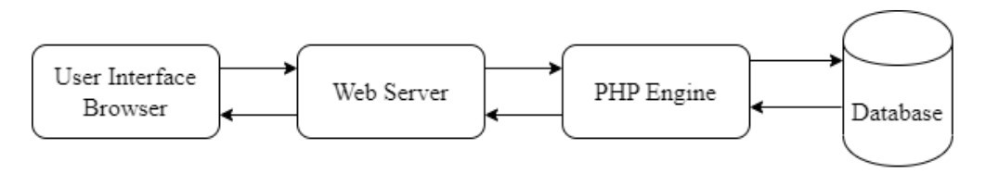

Figure 1: System Architecture

4.5.2 Database Design
The database design for the Electronic Box for Multi-Campus Setting is structured to ensure data integrity, confidentiality, and efficient retrieval of feedback records. The primary database tables include: Users, which stores user credentials, roles, and campus affiliations; Suggestions, which records submission content, category, campus, anonymity status, tracking code, and current status; Responses, which stores administrator replies linked to specific suggestions; Campuses, which maintains a list of all Busitema University campuses; and Categories, which defines the feedback categories such as academic, facilities, welfare, and administration. Primary keys, foreign key constraints, and appropriate indexes are defined on all tables to support efficient querying and referential integrity. Password hashing is applied to all stored user credentials to protect account security.

4.5.3 Entity Relationship Diagram
The Entity Relationship Diagram (ERD) illustrates the logical structure of the system database, identifying the key entities and their relationships. The primary entities and relationships are as follows:
User to Suggestion: A one-to-many relationship, as one user can submit multiple suggestions. For anonymous submissions, the user identity is masked in the administrator view but retained in the database for tracking purposes.
Campus to Suggestion: A one-to-many relationship, where each suggestion is associated with a specific campus. This relationship enables the automatic routing of submissions to the corresponding campus administrator.
Category to Suggestion: A one-to-many relationship, where each suggestion falls under a specific category such as welfare, library, security, or academic matters.
Administrator to Response: A one-to-many relationship, where a campus administrator can provide multiple responses or status updates across different suggestions assigned to their campus.
Suggestion to Response: A one-to-many relationship, where a single suggestion may receive multiple administrative responses over time as its status progresses from pending to resolved.
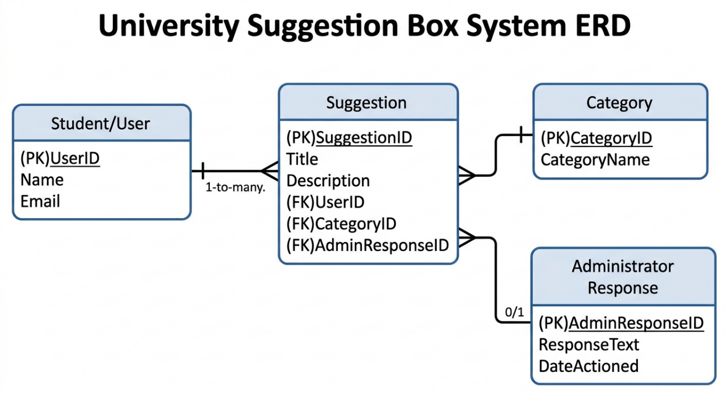
Figure 2: Entity Relationship Diagram

4.5.4 Data Flow Diagram
The Data Flow Diagram (DFD) represents the flow of information within the Electronic Box for Multi-Campus Setting, illustrating how data moves between processes, data stores, and external entities.
Level 0 (Context Diagram): The context diagram shows the system as a whole, with Students and Staff providing suggestion input and receiving status notifications and responses, while Campus Administrators receive routed suggestions and submit action updates and responses.
Level 1 DFD: The Level 1 DFD breaks down the main system processes into specific modules: User Authentication, which handles registration and login; Suggestion Submission, which captures and validates user input; Suggestion Routing, which automatically assigns submissions to the appropriate campus administrator based on campus selection; Suggestion Management, which allows administrators to view, filter, and respond to submissions; Notification Management, which triggers alerts to users when submission statuses are updated; and Report Generation, which enables administrators to export analytics and summary reports.
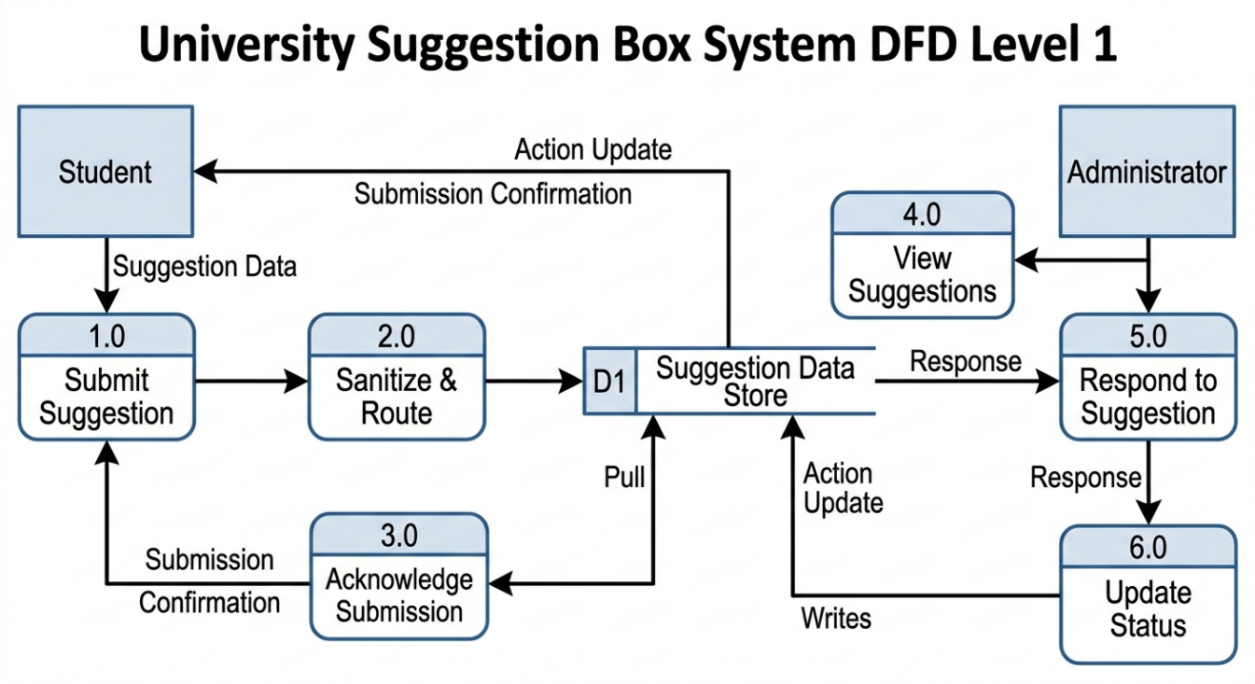
Figure 3: Data Flow Diagram

4.5.5 Interface Design
The interface design for the Electronic Box for Multi-Campus Setting adopts a user-centric approach to ensure a seamless and intuitive experience for all users across Busitema University campuses. The key interface components are described as follows:
- Login Interface: The system gateway features a clean, university-branded login screen with fields for user credentials and a secure password entry mechanism to ensure only authorized members of the Busitema University community access the portal.
- Registration Page: New users are registered through a structured form capturing their full name, campus affiliation, role, email address, and a secure password.
- Student Dashboard and Suggestion Form: The core student interface features a simplified submission form where the user selects a campus, chooses a category, enters a subject title, provides a detailed description, and optionally activates the anonymity toggle to hide their identity from administrators.
- Feedback Tracking Interface: This digital interface provides the user with a tracking history displaying the status of their previous submissions using color-coded labels: Pending (received by the system), Under Review (being processed by the relevant campus administrator), and Resolved (action has been taken and a response has been posted).
- Administrator and HOD Dashboard: This restricted interface enables administrative staff to view incoming suggestions assigned to their campus, sort and filter by urgency, category, or date, and post official responses directly to the user portal.
- Administrator Management Portal: Provides system administrators with comprehensive controls for managing user accounts, campus records, categories, and system-wide suggestion reports.
- Report Page: The reporting interface enables administrators to generate and export summary statistics on suggestion volumes, status distributions, and campus-level trends to support data-driven institutional decision-making.

4.5.6 Use Case Diagram
The Use Case Diagram provides a graphical representation of the interactions between the system users (actors) and the functional capabilities of the Electronic Box for Multi-Campus Setting. The primary actors are the Student or Staff User, the Campus Administrator, and the System Administrator.
The Student or Staff User can register an account, log in, submit a suggestion, choose anonymous submission, track suggestion status, and view administrator responses. The Campus Administrator can log in, view suggestions assigned to their campus, filter and sort submissions, post responses, and update suggestion statuses. The System Administrator can manage user accounts, manage campuses and categories, view all suggestions across campuses, and generate system-wide reports.
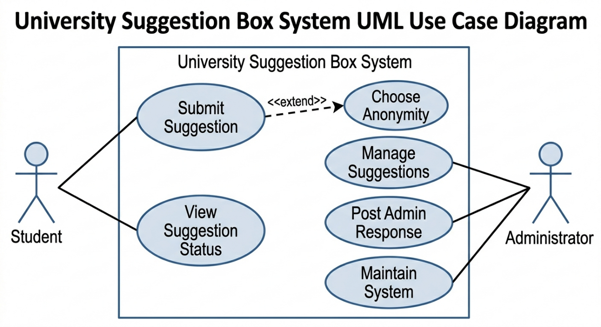
Figure 4: Use Case Diagram for suggestion box system

CHAPTER FIVE:

SYSTEM IMPLEMENTATION AND TESTING

5.0 Introduction
This chapter presents the implementation of the Electronic Box for Multi-Campus Setting, describing the interfaces developed for each user role and the testing carried out to validate the system functionality. The system was implemented as a web-based application using PHP, HTML, CSS, JavaScript, and MySQL, following the design specifications established in Chapter Four.

5.1 System Implementation
System implementation involved translating the design specifications into a working web-based application. The system was developed iteratively, with each module coded, integrated, and tested before proceeding to the next. The programming languages used were HyperText Markup Language (HTML5), Cascading Style Sheets (CSS3), JavaScript, PHP, and MySQL for database management. Bootstrap was incorporated to ensure a responsive and mobile-friendly interface accessible across all Busitema University campuses.

5.2 Interface Design
The goal of the user interface design was to make the system interaction as simple and efficient as possible for both students and administrators. The interface focuses on visual clarity, responsiveness, and a navigation flow tailored to the specific needs of Students, Lecturers, Campus Administrators, and System Administrators. Functional and non-functional requirements were translated into a series of user-friendly screens designed to minimize the steps required to submit or manage feedback.
Below are the descriptions and mockups for the system interfaces:

5.2.1 Login Interface
The login interface serves as the gateway to the Electronic Box for Multi-Campus Setting. It features a clean, university-branded design with input fields for the user's name and password. The interface includes client-side and server-side validation to prevent unauthorized access. Upon successful authentication, users are redirected to their role-specific dashboard. An error message is displayed if incorrect credentials are entered, and the system denies access accordingly.
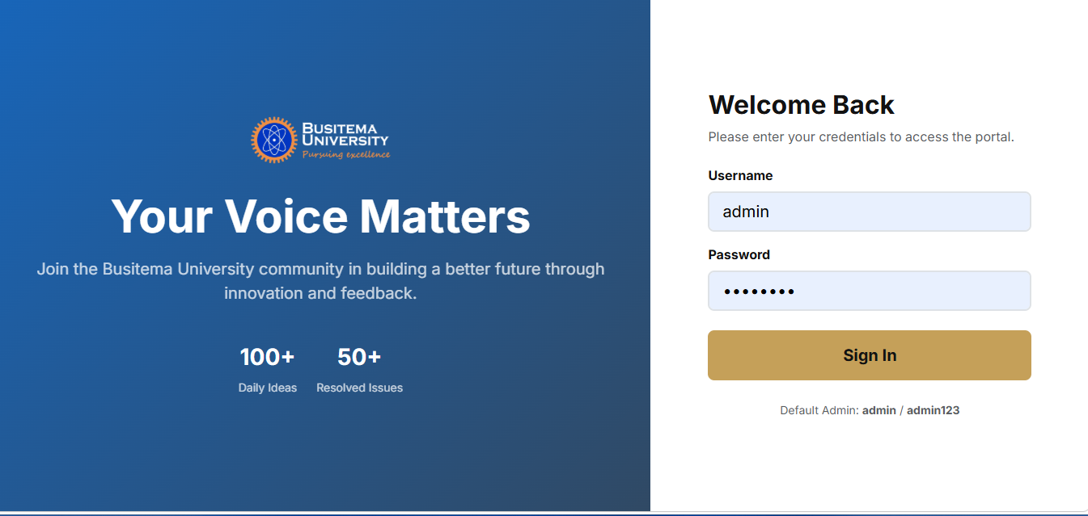
Figure 5: Login Interface

5.1.3 Registration Page
The registration interface allows new users to create accounts within the system. The form captures the user's full name, campus affiliation, user role (student, lecturer, or staff), department, faculty, and a secure password. Input validation is applied to all fields to ensure data accuracy and completeness before submission. Upon successful registration, the user account is stored in the database and the user is directed to the login page.
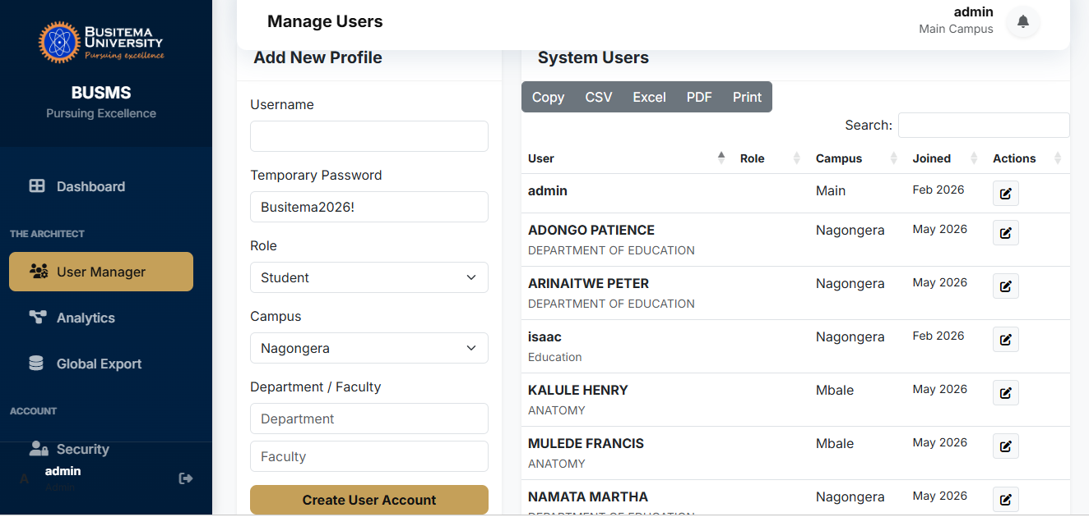
Figure 6: Registration Page

5.1.4 Student Dashboard and Suggestion Form
The student dashboard is the core interface through which students and staff interact with the system. It provides a personalized view of the user's submission history and a prominent access point for submitting new suggestions. The suggestion form allows the user to select their campus, choose a relevant category (such as Academic, Facilities, Health, or Welfare), enter a subject title, and provide a detailed description of their suggestion or complaint. An anonymity toggle switch enables users to choose whether to hide their identity from campus administrators.
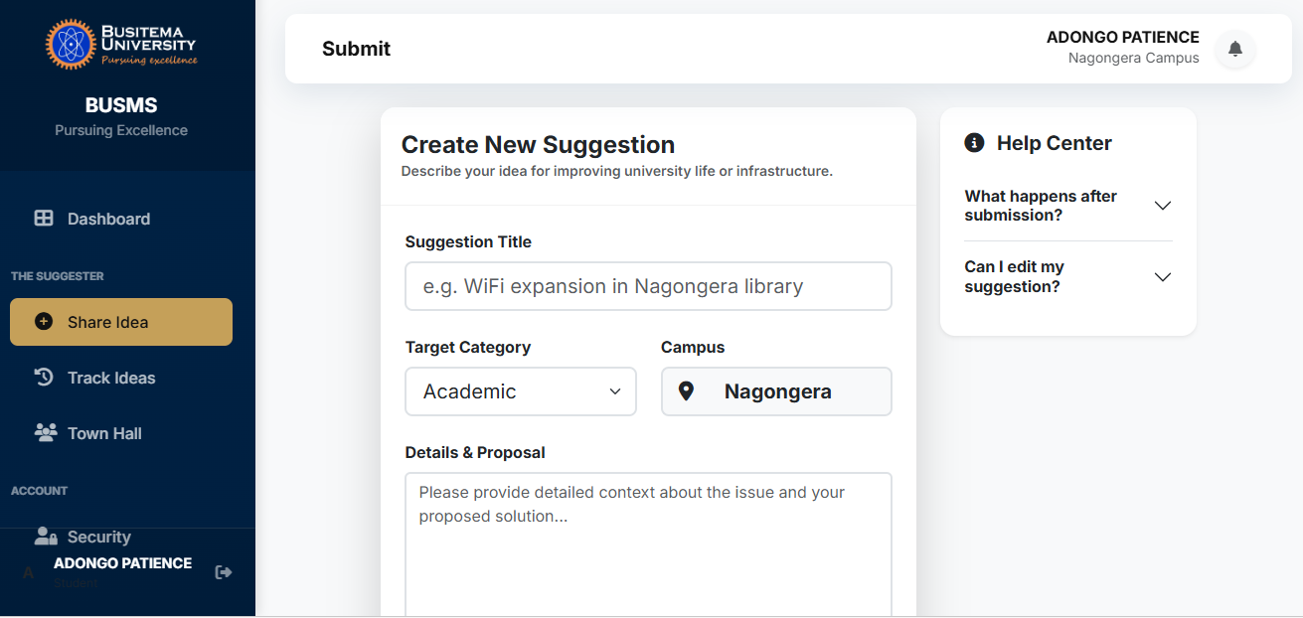
Figure 7: Student Dashboard and Suggestion Form

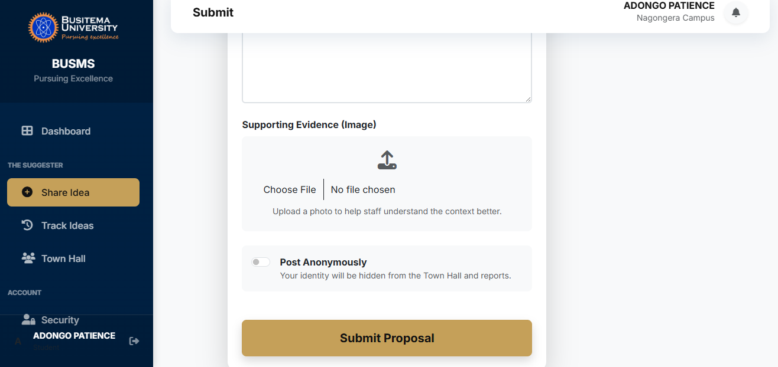
Figure 8: Student Dashboard and Suggestion Form

5.1.5 Feedback Tracking Interface
The feedback tracking interface provides users with a real-time view of the status of their submitted suggestions. Unlike the manual physical system where submissions disappear without acknowledgement, this digital interface displays a comprehensive tracking history for each submission. Status labels are displayed using color-coded indicators: Pending (yellow) indicates the submission has been received by the system; Under Review (brown) indicates the suggestion is being assessed by the relevant campus administrator; and Resolved (green) indicates that action has been taken and an official response has been posted. Users can view the administrator's response directly within this interface.
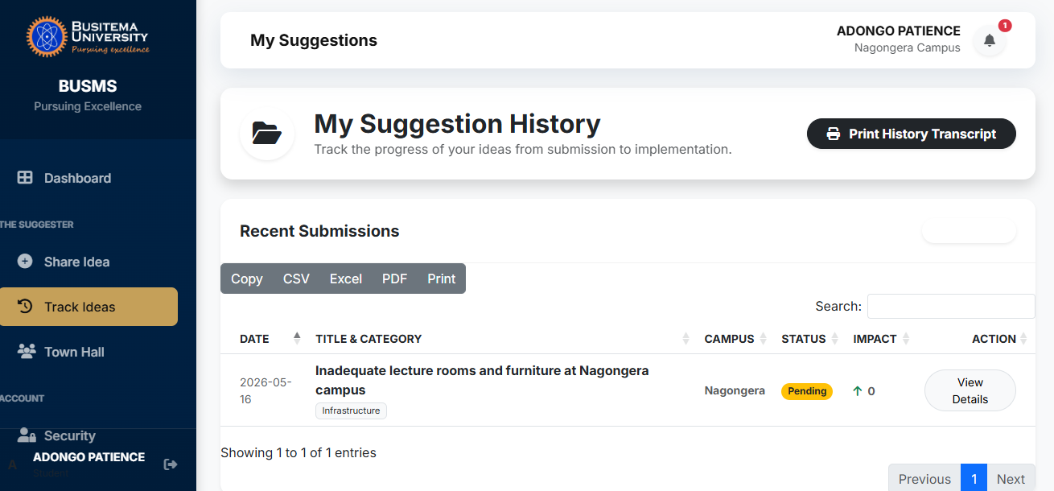
Figure 9: Feedback Tracking Interface

5.1.6 Administrator / HOD Dashboard
The Administrator and Head of Department (HOD) dashboard is a restricted interface accessible only to authorized administrative staff. It provides a comprehensive overview of all suggestions submitted to a specific campus, displayed in a structured list format. The dashboard allows administrators to filter suggestions by category, date, urgency, or status and to view the full content of each submission. Administrators can post official responses directly within the dashboard, and the system automatically notifies the submitting user when a response is provided or a status update is made.
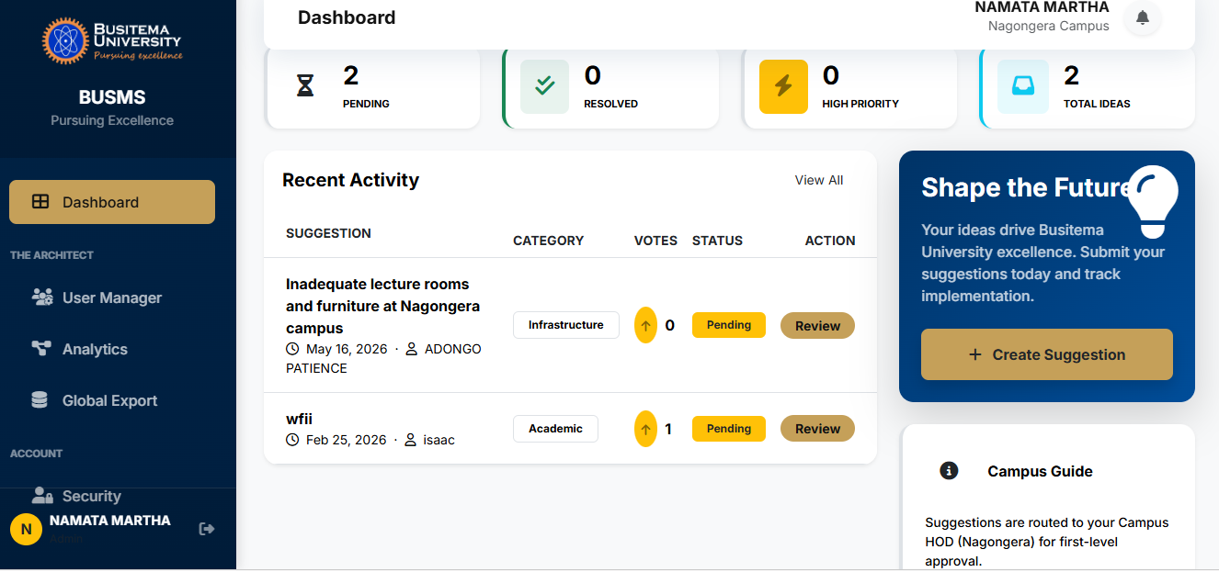
Figure 10: Administrator / HOD Dashboard

5.1.8 Report Page
The report page enables authorized administrators to generate and export summary statistics on the Electronic Box for Multi-Campus Setting. Reports can be filtered by campus, category, time period, and suggestion status. The reporting interface uses Chart.js to display visual analytics showing suggestion trends, resolution rates, and campus-level distributions. Administrators can export reports in printable formats to support institutional decision-making and governance reporting.
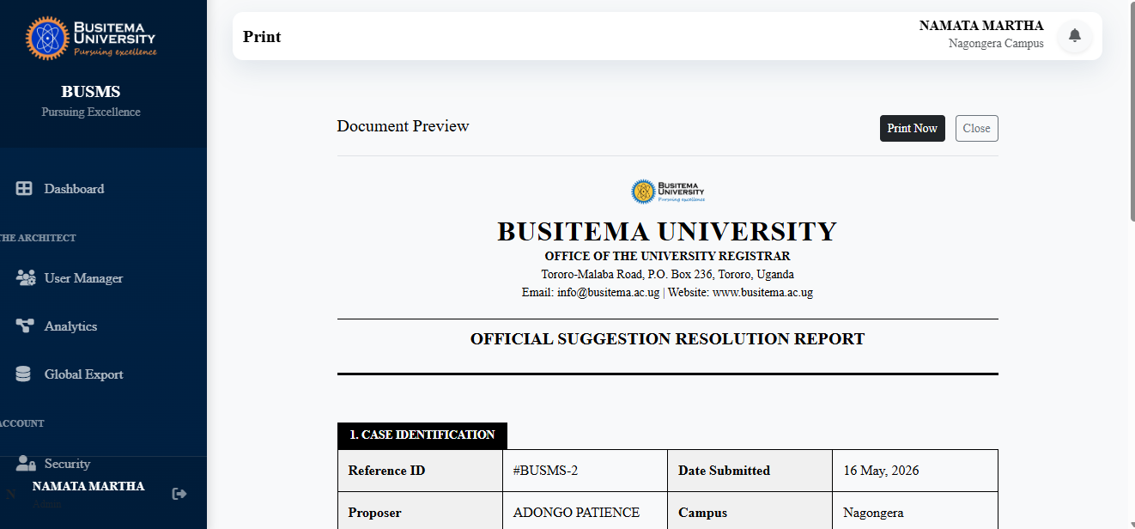
Figure 11: Report Page

5.3 System Testing
System testing was conducted at multiple levels to ensure the correctness, usability, and security of the implemented Electronic Box for Multi-Campus Setting. The testing phases included unit testing, integration testing, user acceptance testing, and security testing.

5.3.1 Unit Testing
Individual functions and modules were tested in isolation to verify that each component performed its intended operation correctly. Test cases were executed for user authentication, suggestion submission, status updates, response posting, and report generation.

5.3.2 Integration Testing
Modules were tested together to verify that data flowed correctly between the submission, routing, and administration components. Cross-campus routing was specifically validated to confirm that suggestions were assigned to the correct campus administrator inboxes based on the campus field selected during submission.

5.3.3 User Acceptance Testing (UAT)
Selected students, lecturers, and administrators from the sample group interacted with the system and evaluated it against their initial requirements. UAT feedback was used to refine the interface and correct identified deficiencies. Participants confirmed that the system was easy to use, that anonymous submission worked correctly, and that feedback tracking provided clear and timely status updates.

5.3.4 Security Testing
The system was tested for common vulnerabilities including SQL injection, cross-site scripting (XSS), session hijacking, and unauthorized access to role-restricted pages. Identified vulnerabilities were addressed before final deployment to ensure the system met data privacy and confidentiality requirements.
The table below provides a summary of the key functionality test results conducted during the testing phase.
Table 1: Security Testing
S/N | TEST CASE | EXPECTED RESULTS | ACTUAL RESULTS
1 | Login Function | User successfully logged in after entering their correct username and password. | Results as expected.
 | Wrong Login Details | System denies access and displays an “Invalid Credential” error message. | Results as expected.
2 | Students Registration | New user details are successfully captured and stored in the database. | Results are expected.
3 | Submit suggestion | The suggestion text, category and anonymity status are correctly stored in the database. | Results as expected
4 | View Feedback Status | The logged in student can view the real time status (Pending/Resolved) of their submissions. | Results are expected.
5 | Admin Response | Administrators reply is successfully linked to the specific suggestion and visible to the student. | Results as expected.

CHAPTER SIX:

DISCUSSION, CONCLUSION, RECOMMENDATIONS, LIMITATIONS AND FUTURE WORK

6.0 Introduction
This chapter presents a discussion of the results of the study in relation to the stated objectives, followed by the conclusion, recommendations, limitations, and future work arising from the development and implementation of the Electronic Box for Multi-Campus Setting at Busitema University.

6.1 Discussion of Results
The Electronic Box for Multi-Campus Setting was developed to address the persistent communication and feedback management challenges faced by Busitema University. The results of the implementation are discussed below in relation to each of the four specific objectives of the study.

6.1.1 Objective 1: To review the literature and determine the requirements necessary to develop an electronic box for multi-campus setting.
The literature review conducted in Chapter Two confirmed that manual suggestion boxes are inadequate for modern multi-campus institutions. Related studies by Nwosu (2020), Kumar and Singh (2023), and Ochieng (2020) collectively established that digital feedback systems significantly improve stakeholder participation, transparency, and administrative responsiveness in higher education. The review further identified critical gaps in existing systems, particularly the absence of multi-campus routing, anonymous submission mechanisms, and real-time tracking features in systems deployed in Sub-Saharan African university contexts. These findings directly informed the functional and non-functional requirements specified in Chapter Four, ensuring that the developed system addressed identified gaps in the existing body of knowledge.

6.1.2 Objective 2: To analyze data requirements and design the system.
Data requirements were gathered through structured interviews, direct observation, and document review conducted at Busitema University campuses. Analysis of collected data revealed key user needs including anonymous submission, campus-specific feedback routing, real-time status tracking, and administrator response capabilities. The system design presented in Chapter Four translated these requirements into a comprehensive system architecture, database design, entity relationship diagram, data flow diagram, interface designs, and use case diagram. The design successfully addressed the multi-campus routing requirement by implementing campus-based suggestion assignment logic that automatically routes submissions to the appropriate campus administrator, a feature not found in previously studied systems.

6.1.3 Objective 3: To implement an electronic box for multi-campus setting.
The system was successfully implemented as a web-based application using PHP, HTML5, CSS3, JavaScript, Bootstrap, and MySQL. All key modules were developed and integrated, including user authentication, suggestion submission, campus-based routing, administrator dashboards, feedback tracking, notification management, and report generation. The implementation demonstrated that a centralized electronic suggestion box capable of serving multiple campuses simultaneously is achievable using widely available and cost-effective open-source technologies. The responsive interface ensured accessibility from both desktop computers and mobile devices, supporting participation from students and staff across all Busitema University campuses regardless of the device available to them.

6.1.4 Objective 4: To test and validate the functionality and efficiency of the electronic box for multi-campus setting.
System testing was conducted through unit testing, integration testing, user acceptance testing, and security testing as described in Chapter Five. All key functional requirements were validated successfully. Unit tests confirmed that individual modules performed their intended operations correctly. Integration tests verified that cross-campus routing assigned suggestions to the correct administrator inboxes. User acceptance testing conducted with students, lecturers, and administrators from the sample group confirmed that the system was intuitive, functional, and met the communication needs of stakeholders across campuses. Security testing identified and addressed vulnerabilities prior to deployment. Overall, testing results validated that the Electronic Box for Multi-Campus Setting is functional, secure, accessible, and effective in improving feedback management and institutional communication at Busitema University.

6.2 Conclusion
The Electronic Box for Multi-Campus Setting was developed to streamline the process of submitting, tracking, and managing institutional feedback across Busitema University campuses. The system successfully replaces the inefficient manual suggestion box system with a centralized, secure, and accessible digital platform that promotes transparency, accountability, and stakeholder participation in institutional governance. The system allows users to submit suggestions anonymously or with identification, track submission statuses in real time, and receive direct responses from campus administrators. Administrators benefit from organized dashboards, automated routing, and comprehensive reporting tools that support data-driven decision-making. The study has achieved all four specific objectives stated in Chapter One, and the implemented system meets the functional, non-functional, and technical requirements defined during the analysis phase.

6.3 Recommendations
Based on the findings of this study, the following recommendations are made:
It is recommended that Busitema University formally adopt and integrate the Electronic Box for Multi-Campus Setting into its official digital infrastructure to ensure all registered students and staff have access to a centralized platform for submitting and tracking institutional feedback.
University management should conduct awareness campaigns and training sessions to sensitize students, lecturers, and administrators on how to use the system effectively, particularly emphasizing the anonymity feature to encourage honest and candid participation.
Other multi-campus institutions in Uganda and the broader East African region that still rely on manual suggestion systems are encouraged to adopt similar electronic feedback platforms to improve stakeholder engagement, institutional transparency, and administrative responsiveness.
ICT departments in higher education institutions should develop sustainable maintenance plans and technical support frameworks to ensure the long-term reliability and availability of digital feedback systems deployed across multiple campuses.

6.4 Limitations
The following limitations were encountered during the course of this study:
- Geographical Specificity: The system was implemented and tested primarily within the Faculty of Science and Education at Busitema University, Nagongera Campus. The findings and system performance may not fully generalize to other campuses or institutions with different administrative structures.
- Sample Size: The study relied on a purposive sample of approximately 20 to 30 respondents from among students, lecturers, and administrative staff. This sample may not fully represent the diverse needs of the entire university population across all campuses.
- Resource Constraints: Limited access to high-speed internet during the development and testing phase, along with insufficient funds for commercial server hosting, constrained the scope of deployment and performance testing under high-traffic conditions.
- Incomplete Responses: Some respondents did not complete all items in the data collection instruments during requirement gathering, leading to minor gaps in the understanding of certain user expectations.

6.5 Future Work
While the Electronic Box for Multi-Campus Setting has achieved its core objectives, several enhancements are proposed for future development:
Mobile Application Development: A dedicated Android and iOS mobile application should be developed to provide push notifications when suggestions are replied to or when status updates are made, improving real-time communication with users.
API Integration: The Twilio API or similar SMS gateway should be integrated to send instant text message updates to users regarding the status of their submissions, extending system accessibility to users without consistent internet access.
Artificial Intelligence and Sentiment Analysis: Natural Language Processing (NLP) techniques should be implemented to automatically categorize and prioritize suggestions based on the urgency, sentiment, and recurring themes identified in submission content, reducing administrative workload.
Cloud Hosting: The system should be migrated to a commercial cloud hosting platform to enhance security, enable automated data backups, improve scalability, and ensure 24/7 accessibility across all campuses.
Multi-Language Support: Future versions of the system should incorporate support for local languages commonly used by stakeholders across different Busitema University campuses to further promote inclusivity and participation.

REFERENCES
Nwosu, C. (2020). Development of an Online Suggestion Box for Academic Institutions. International Journal of Computer Applications, 176(2), 55–62.
Adebayo, T., & Olayinka, S. ( 2020). The role of feedback systems in improving organizational communication. International Journal of Management Studies, 12(2), 45–59.
Amini, N., et al. . (2025). Development of Smart Digital Interactive Services: A Strategy for Guidance and Communication in Higher Education. . PMC Journal of Educational Technology, 12(4), 102-118.
Bradley, S. ( 2021). The Strategic Use of ICT for Real-Time Feedback and Assessment in the Modern Classroom. Journal of Digital Learning in Higher Education, 9(1), 237-244.
Chen, L., Wang, J., & Zhao, Y. . (2021). Web based communication systems for institutional feedback. . Information and Management, 58(4), 231–245.
Etikan, I., Musa, S. A., & Alkassim, R. S. ( 2016). . Comparison of convenience sampling and purposive sampling. American Journal of Theoretical and Applied Statistics, 5(1), 1–4.
Fitzgerald, B. (2000). Systems analysis and design: An interdisciplinary approach. McGraw Hill.
Kariuki, J. (2019). Transparency and accountability in organizational communication systems. . Journal of Public Administration Studies, 6(2), 34–46.
Kassim, M., & Abdulrahman, A. (2021). ICT adoption in organizational communication systems. Journal of Information Technology Development, 14(1), 55–68.
Kumar, R., & Singh, P. ( 2023). Web based suggestion management systems for organizational development. International Journal of Information Systems and Technology, 11(2), 78–90.
Loglo, F. S., & Zawacki-Richter, O. . (2023). . Learning with Digital Media: A Systematic Review of Students’ Use in African Higher Education. Journal of Learning for Development, 10(1), 15-32.
Mutiso, D., & Mwangi, J. . (2023). Digital suggestion systems and institutional decision making. Journal of ICT and Society, 15(2), 90–104.
Nwosu, C. (2020). Development of an Online Suggestion Box for Academic Institutions. International Journal of Computer Applications, 176(2), 55–62.
Ochieng, A. (2020). Modernizing Feedback Mechanisms in Educational Settings. . International Journal of Education Management, 8(3), 112-125.
Ochieng, R. ( 2020). Challenges of traditional suggestion boxes in modern organizations. . East African Journal of Management, 7(1), 29–38.
Okafor, I., & Musa, A. (2021). Digital feedback systems and stakeholder engagement. . Journal of Organizational Communication, 10(4), 70–84.
Omondi, P. (2020). Organizational communication and employee participation. African Journal of Business Communication, 5(1), 41–52.
Shaw, D. (2020). Modern system analysis and design methodologies: An overview. Journal of Information Systems Design, 7(3), 45–62.
Ukeme, E., Uford, I., & Etuk, S. . (2024). Digital Communication in Organizations: Trends, Strengths, and Weaknesses in the Post-Pandemic Era. ResearchGate. International Journal of Business & Management.
Williamson, B., Komljenovic, J., & Gulson, K. N. . (2024). Digitalised Higher Education: Key Developments, Questions, and Concerns. Taylor & Francis: Critical Studies in Education.
Yeboah, T., & Boateng, E. ( 2021). Enhancing transparency through digital suggestion platforms. Journal of ICT Innovation, 10(2), 33–45.

APPENDICES

APPENDIX 1: INTERVIEW GUIDING QUESTIONS

A For Students
1. How do you currently submit suggestions or complaints to university management?
2. How satisfied are you with the current suggestion box system? Please explain.
3. Have you ever submitted a suggestion using the physical suggestion box? What was your experience?
4. Do you receive any feedback or response after submitting a suggestion? How long does it usually take?
5. What features would you find most useful in a digital suggestion box system?
6. Would you be comfortable submitting suggestions anonymously through a digital platform? Why or why not?
7. Do you have reliable access to the internet on your campus? On which devices do you most commonly access online services?
8. What challenges do you face when trying to communicate concerns to university administration?

B For Lecturers
1. How do you currently communicate academic or administrative concerns to university management?
2. What limitations have you experienced with the current physical suggestion box system?
3. How important is it to you to receive feedback or acknowledgement when you raise a concern? How is this currently handled?
4. What functionalities would you recommend for an electronic suggestion box system to make it useful for lecturers?
5. How do you feel about the idea of anonymous submissions in an institutional feedback system?
6. What concerns, if any, do you have about the adoption of a digital feedback platform across multiple campuses?

C For Administrators
1. How does the university currently collect and manage feedback from students and staff?
2. What are the main challenges you face in managing suggestion boxes across multiple campuses?
3. How are suggestions currently categorized, prioritized, and responded to?
4. What reporting or analysis of feedback is currently conducted, and how?
5. What features would make a digital suggestion management system most useful to you as an administrator?
6. How do you currently ensure that suggestions from remote campuses reach the relevant administrative offices in a timely manner?
7. What security and privacy concerns would you want addressed in a digital suggestion box system?
8. What support or training would be needed for successful adoption of a digital feedback platform across Busitema University campuses?

